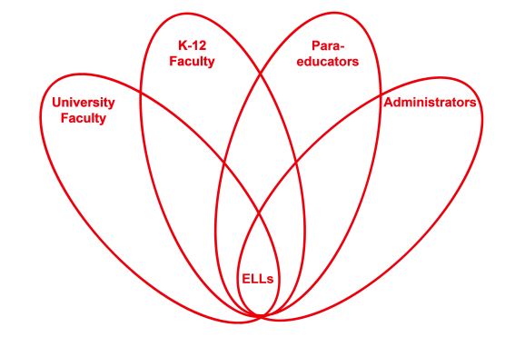

RETELL Strategy Implementation in the Classroom

Teacher | Andrew Larocque
Content Area /  Grade Level | Algebra 1/ Grade 9
Unit  (Topic or Skill) | This strategy can be done after teaching both the substitution and elimination method for solving systems of equations.
Content Objectives | SWBAT:  - Solve systems of equations using either the substitution or elimination method
Language Objectives | - Students will write the steps to solving the system of equations using the write around strategy.
Strategy | Write Around
Brief explanation of how the strategy was used | The Write Around activity was modified for my Algebra 1 class. I took four different systems of equations problems and solved them on different sheets of paper. Two of the systems of equations were solved using the substitution method and the other two were solved using the elimination method. On the sheet of paper I put a blank space for the students to write in the steps they observed. Each step was labeled A through J and there were blank spaces with the same labels so the students would know where to write the corresponding steps.  As the students entered my class they started the Do Now. It was for the students to solve two of the system of equations that were going to be given in the Write Around strategy. The first problem used the substitution method and the second problem used the elimination method. After approximately ten minutes of the students working independently, I went to the board where we solved the two system of equations. The students seemed confident in solving system of equations. Then I put the students in groups of four and handed out the sheets for the Write Around strategy. I explained that the students had to write down any step they observe on one of the blank lines and pass it clockwise. Then with the new paper they were instructed to write down a step they observed and pass it clockwise. This would continue until each blank line was filled in with a step. After all the steps were written, each student had to read their system of equations. The students had to make sure they were correct. Finally I had each group read a different system of equations aloud to the class.
Reflection: How and why was the strategy effective? What might you change for next time? | What was amazing was that the students could complete the mathematics of solving the system of equations during the Do Now but when asked to write the steps they struggled. At first they kept saying I know what to do I just cannot explain it. I reassured them that they only needed to write one step that they observed. Some students seemed overwhelmed so I helped the students by pointing at some steps and asking what they saw. They would say the step aloud but it took a couple of times for the students to realize what they were saying is what they needed to write. Since the students usually just follow steps that are already written it was a struggle for them to actually write the steps for themselves. This strategy made the students look at a math problem and analyze what they actually were observing which is different than just following a bunch of steps to get the answer. The strategy made the content more comprehensible because they were not following a process but analyzing a process.  The students then had to read it to each other and make sure all the steps were correct. This part seemed to fit another strategy, Cut-n-Grow, because the students put steps in the wrong spot and then were missing some steps. This was a good opportunity for the students to analyze the steps as a whole and listen to one another and figure out if a step did not fit. The students worked together and discussed. Once everyone knew they had the correct steps, we came together as a whole class to listen to each group read one of the four systems of equations.  Write Around strategy helped all of the students improve their academic language. The students had to analyze and then write the steps they observed. At first the students had to say the step aloud in order for them to write it. They had to hear themselves use the academic language before they could write it. The students were writing using the academic language. Each student was helping one another because they had to read what their partner wrote for a step and see how their step interacted with the step they wanted to write. This seemed to be an interactive way for the students to be engaged with the academic language.  After all four sheets were completed, the students had to listen to their partner read the steps which were in academic language. As they were listening they had to analyze if the steps were in the correct order or even the correct steps. This gave each student a chance to read, write and listen to one another using the academic language. The students went through the steps fixing mistakes by putting in steps and changing the order to the steps they wrote.  When the groups read one of the systems of equations aloud to the class, I repeated the steps if necessary modeling the correct academic language. This gave the students the reassurance that what they had written was correct because they heard their peer explain the steps and then me model any corrections that had to be made in writing the steps to solve the systems of equations.  Next time I did this strategy I might include a steps bank. It would have been a word bank but for steps. This would have helped a number of students who struggled to get started because the whole process seemed overwhelming to them. I could even have written a couple steps in to give the students a better example of what would be expected of them. Having modified this strategy to mathematics caused another layer of confusion but after a few moments with each group, they understood the expectations.  I could also extend this strategy to include the Cut-n-Grow. The students were doing it by crossing in steps and writing in steps. I could very easily have had them cut the steps out and tape them to a colorful piece of paper.

**See handouts on the following pages**

Names:_____________________________________________________________________________________________________________________________________________________________________________________________
Write Around: System of Equations
The system of equations is solved. Write one of the steps and pass it to a partner in the group. Each partner writes one step and passes until each step has been written. At the end one of the partners reads all the steps to the group.

- $4x+5y=11$
$$y=3x-13$$
- $4x+5\left(3x-13\right)=11$
- $4x+15x-65=11$
- $19x-65=11$
- $+65 +65$
$$19x=96$$
- $\frac{19x}{19}=\frac{96}{19}$
$$x=4$$

- $y=3x-13$
- $y=3\left(4\right)- 13$
- $y=12-13$
- $y=-1$

- $(4,-1)$

Method: ________________________

- _____________________________

- _____________________________

- _____________________________

- _____________________________

- _____________________________
- _____________________________
- _____________________________
- _____________________________
- _____________________________

- _____________________________

