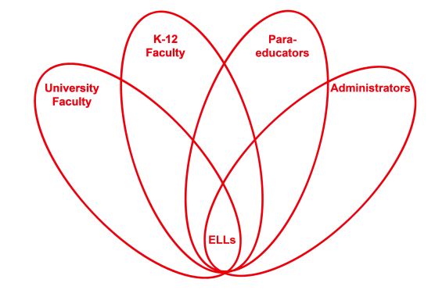

RETELL Strategy Implementation in the Classroom

Teacher | Kate Vachon
Content Area /  Grade Level | Kindergarten
Unit  (Topic or Skill) | The Biggest, Best Snowman by Margery Cuyler
Content Objectives | Students will use sequential vocabulary words such as first, next, then, last when describing the steps in building a snowman.
Language Objectives | Students will retell the sequential steps to building a snowman with the use of a visual model to refer to (the actual completed snowman).  Students are able to point to the part of the snowman that was put on if he/she does not have the word for the object. The teacher will name the object and model an appropriate sentence to describe the step if necessary.
Strategy  (Name or Type) | Write Around
Brief explanation of how the strategy was used | The teacher has already read the book to the class the day before the lesson and discussed how all the characters worked together to build a snowman and the students were put into group to “build” a snowman using selected craft materials. The class has been working on the vocabulary terms first, next, then and last.  Lesson: The teacher re-reads the book. The students are then reminded about the process they went through the day before to “build” their snowman. They are asked to think about their experience and the order in which a snowman should be built.  The teacher then engages the students in a discussion about how they decided what materials to use and the order in which to “build” their group snowman. The teacher then asks the students what order a snowman should be built and records their answers on chart paper encouraging the students to use the words, First, Next, Then, Last. Students are asked to come up periodically and write known words or the first letter of a word.  Once all the steps have been recorded, the teacher reads them back to the class.  Steps chart should be hung near the bulletin board when the group snowmen are hung.
Reflection: How and why was the strategy effective? What might you change for next time? | The students loved this activity, and the group snowman “building” activity. They were able to use the vocabulary terms and each student was able to write at least one thing on the steps chart.  If possible I would have the class build a real snowman outside.

