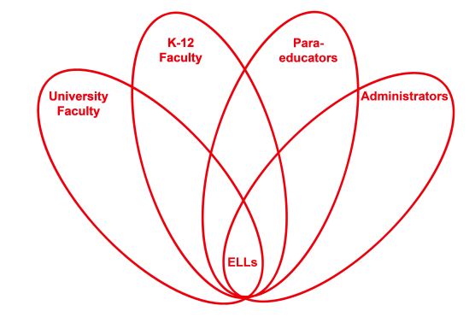

RETELL Strategy Implementation in the Classroom

Teacher | Linda Fiorillo
Content Area /  Grade Level | Literacy/Kindergarten
Unit  (Topic or Skill) | The Gingerbread Man-(Character identification)
Content Objectives | Students will be able to identify the characters of the story of The Gingerbread Man
Language Objectives | Students will write at least one character name from the story of The Gingerbread Man and add it to a group list in a given time period.  Language Objective Differentiation for Proficiency Levels:  L1 Students will recall and write one character from the  story of The Gingerbread Man a given time period  L2 Students will read characters from a generated list and  write one additional character from the story of The  Gingerbread Man a given time period.  L3 Students will read characters from a generated list and  write one or more additional characters from the story of  The Gingerbread Man in a given time period.
Strategy | Write Around
Brief explanation of how the strategy was used | Procedure  Teacher explained and demonstrated the “Write Around” strategy so that students could understand what was expected of them at activity time.  Next, teacher strategically placed lower ELLs with higher ELLs or English proficient children and together they read a student version of The Gingerbread Man.  After that, the students were divided into 4 groups and were asked to go to a table. At the table was a large sheet of paper. They were to think of a character in the story of The Gingerbread Man and write it on a piece of paper that was rotated from one person to the next. The higher ELL students were encouraged to read the list and write one or more characters in the time frame without repeating one that had already been written. Each student had a minute to try and write their character/s.  Once everyone had a turn, the students remained at the table and discussed their list.  Students assembled as a large group and they shared their lists with lists with the class.  The teacher told them that they will make a book the following day and they will use their group lists to write all the characters on the list in a book to take home to read.  Students were reminded that “The Write Around” strategy helps students to think about what they are writing and expand upon their writing so they can be better writers.
Reflection: How and why was the strategy effective? What might you change for next time? | Modeling always helps the children know what is expected of them and this helps them clearly understand the activity when it is time for them to do it independently. The student book allowed the children to see the words and characters in text as they read them to each other. The write around strategy forced the students to quickly recall the characters from the story and write them down in a limited time. The students were exposed to all the characters through reading, writing, and even listening, and speaking through discussions that followed the activity.  Modeling provided the explicit instruction that is so important for ELL students to learn. The partner read aloud and discussion provided practice for speaking the content words (characters) and listening while concentrating on the characters of the book. The small groups provided a comfortable and safe environment for writing without feeling much pressure. The discussions exposed the students to all the characters and provided the experience for each other to communicate their ideas and hear fluent language being spoken about the academic language. The students could also connect their writing to the book as they recalled and wrote each character.  In Kindergarten, I think I need to give at least 2 minutes to write the word. Although most of my students have mastered the alphabet, some struggled to complete their words before time was up and this frustrated them. Some children really needed help but there was no talking so they either just sat there or kept asking for help from the teacher and the students. I think I will prep them more next time and let them know it is ok to write what they know and to feel comfortable to put something on the page without feeling intimidated. I like the follow-up activity that allows the students to use their lists to make a book about all the characters on the lists so they can read them at home for reinforcement of the content and academic language.

