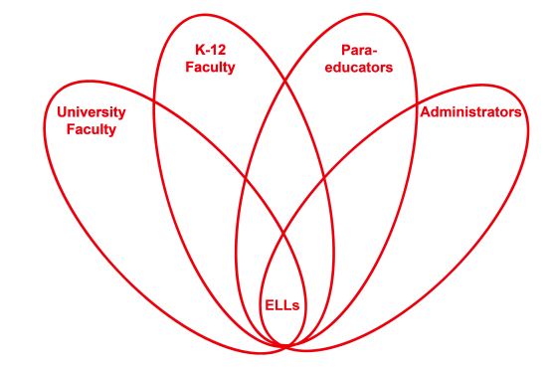

RETELL Strategy Implementation in the Classroom

Teacher | Carlene Hackett
Content Area /  Grade Level | Reading/Grade 4
Unit | Writing in ELA class
Content Objectives | Students will be able to identify key ideas in an informational text.
Language Objectives | Students will write complete sentences in response to reading a non-fiction book about Westward Expansion.
Strategy | Write Around
Brief explanation of how the strategy was used | As a class I read the book “The Journey West” to the class, stopping and having discussions about what it was like to be a pioneer. We charted thoughts, opinions and vocabulary words which has been ongoing throughout this unit.  After spending the past few months studying Westward Expansion, students will use their knowledge to complete the task of writing down 1 sentence about the pioneers during Westward Expansion. There is a word bank in the classroom that has words from this unit for students to refer to. Students are given a few minutes to write one sentence, then they pass it to the right, next student has to read the first sentence and write another one to continue with the topic. This continues until all papers have been around the group. I had groups of six.  These papers are used for another strategy, cut and grow.
Reflection: How and why was the strategy effective? What might you change for next time? | This strategy was an effective way for students to showcase their knowledge on a subject without writing too much. In most cases they had to elaborate on someone else’s paper which could be a problem if the groups are too big. Next time I might make groups smaller.  I have also used this strategy in other academic areas, for example Science. It is not threatening to ELL students due to the limited work they have to complete. It is also great for them to see other students’ work.

