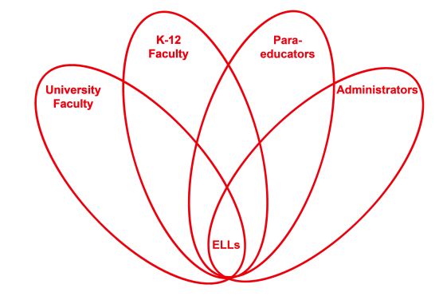

RETELL Strategy Implementation in the Classroom

Teacher | Carolyn Driscoll
Content Area /  Grade Level | ELA Grade 4
Unit  (Topic or Skill) | Westward Expansion
Content Objectives | 4 RL1  I can use details and examples in a text to explain and draw inferences.  After listening to the story “Dandelions”, students will be able to describe an adventure that the Bolton family experiences in the West.
Language Objectives | I can cite details and examples from the text when making inferences.  After listening to the story “Dandelions”, students will be able to write a sentence about an adventure the Bolton family experiences in the West.  Language Objective Differentiation for Proficiency Levels:  Some of my ELLS will orally cite details and examples from the text and others will be able to write about the details.  Level 2s will be given a word bank that includes: wagon, saddle, dandelions, crops, well.
Strategy | Write Around Strategy
Brief explanation of how the strategy was used | Lesson Sequence:  Students have been studying westward expansion.  Whole group lesson.  Teacher reads the book “Dandelions” to the group, pausing to discuss the Bolton family’s adventures in the West. The group is then divided into teams of 4 with the Ell students put on different teams. Each student is given a piece of paper and a pencil. The teacher explains that when given the signal each student can write a sentence describing an adventure the Bolton family has experienced in the West. The teacher then models the sentence “The Bolton family traveled to visit their neighbors the Svensons” on the board. Teacher gives the signal to write, and then at another signal they stop and pass the paper to the right. Student reads what classmate wrote then adds 1 sentence that goes with what was written. This continues until all 4 students have written something. Teams then select 1 paper to be revised as a final product.
Reflection: How and why was the strategy effective? What might you change for next time? | The Write around strategy helps my Ell students by giving them an opportunity to practice their writing skills. Because they have to write just 1 sentence, there is less pressure. Also they are able to see other students’ sentences to help model their own.  This strategy helps students write connections to the text while being part of a team. This will build their confidence as writers. I think it is important to make sure all the ELL students are not on the same team. That is what made this lesson successful

