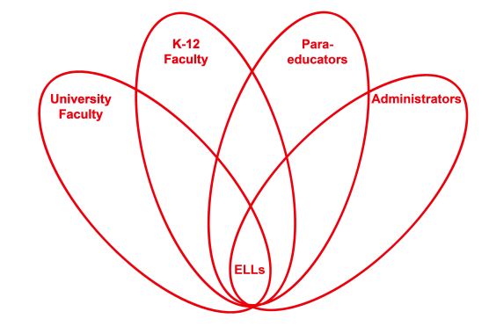

RETELL Strategy Implementation in the Classroom

Teacher | Melissa Carte
Content Area /  Grade Level | Health/ Gr. 3
Unit | Strategies for bystanders
Content Objectives | Students will be able to identify the ways a bystander can help a victim from being bullied.
Language Objectives | CCSS.ELA-Literacy.W.3.1 Write opinion pieces on topics or texts, supporting a point of view with reasons.  CCSS.ELA-Literacy.W.3.1a Introduce the topic or text they are writing about, state an opinion, and create an organizational structure that lists reasons.  CCSS.ELA-Literacy.W.3.1b Provide reasons that support the opinion.  CCSS.ELA-Literacy.W.3.1c Use linking words and phrases (e.g., because, therefore, since, for example) to connect opinion and reasons.  CCSS.ELA-Literacy.W.3.1d Provide a concluding statement or section  Students will be able to describe through writing a paragraph how they would help Chrysanthemum from being bullied if she were in their class.  Language Objective Differentiation for Proficiency Levels:  Levels 1 & 2  Students will be able to describe through using a phrase and word bank how they would help Chrysanthemum from being bullied if she were in their class.
Strategy | Write Around
Brief explanation of how the strategy was used | -Introduce the concept of being a bystander by having 4 students role play a scene of getting in line when the bell rings at recess. Have one student run into the other three in line. Then they begin to argue and fight over being pushed. Have the class imagine that they are all at recess and they are watching what happens when the bell rings. State that they are all bystanders and a bystander is someone who sees or witnesses what happens. When the scene ends have the students discuss with a partner what they would do if they saw students fighting in line.  -Use 7 step process to introduce new vocabulary.  -Read “Chrysanthemum” by Kevin Henkes.  -Discuss through think pair share how Chrysanthemum was treated by her classmates. Why was she made fun of? How did she feel? How do you know? Did she do anything to stop being picked on? Did anyone stick up for her? Who were the bystanders in the story? What did they do? Why do you think they didn’t do anything? Have you ever been afraid to stand up for somebody else?  -Brainstorm a list of phrases of what they would do as bystanders to help Chrsyanthemum if she was in their class and they heard students making fun of her name.  -Put students in groups of four and give each student a paper for a write around.  -Model and have students write the topic sentence “If I were a bystander in Chrsyanthemum’s class, these are the ways I would help her.”  -Use and model transition words such as “First I would” and have students finish the sentence and then pass to the right. Continue the same pattern with “Next I would”, “Then I would” and “Finally I would”.  -Give time for students to read what they have written and then read aloud at the end.  -Next step is to have groups choose which paragraph they want to revise and edit from the group.
Reflection: How and why was the strategy effective? What might you change for next time? | The write around made the content easier to understand because the ELL students were able to discuss what they would do as bystanders to help another student and then were able to use the brainstormed list to write about it during the write around. They also were able to understand how they could help as bystanders by reading what their group members had created for sentences on ways they would assist Chrysanthemum too. The write around helped the ELLs to produce academic language because they were part of a group. They were also able to use the write around as a frame to create sentences about how they as bystanders would help to prevent a fellow student like Chrysanthemum from being bullied and picked on. They also were able to read their fellow students’ input as well and had an additional model of academic language during the write around.  The next time I try this strategy, I would model the write around more slowly by going step by step especially when it came to passing the paper. I would even role play an example with a few students for the class to see the process too. I also would use peer buddies to make the process go smoother.

