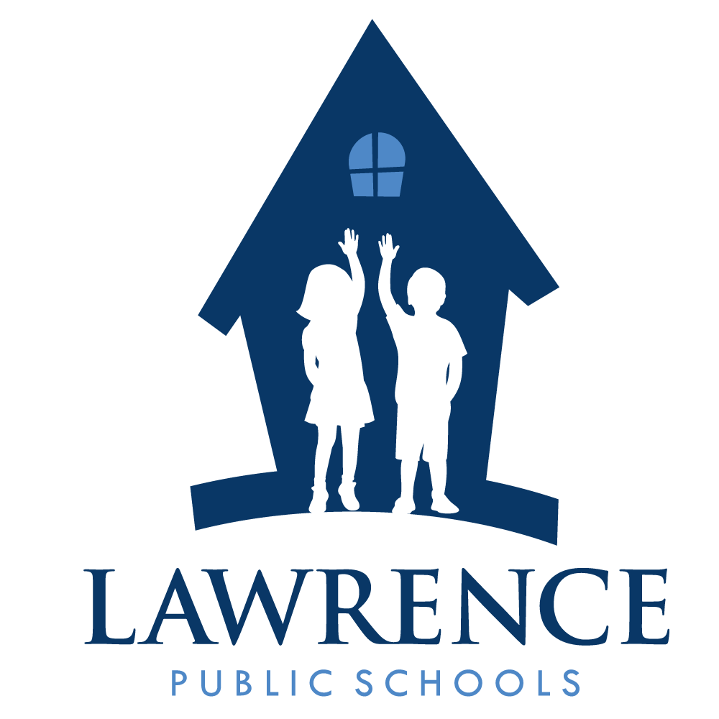
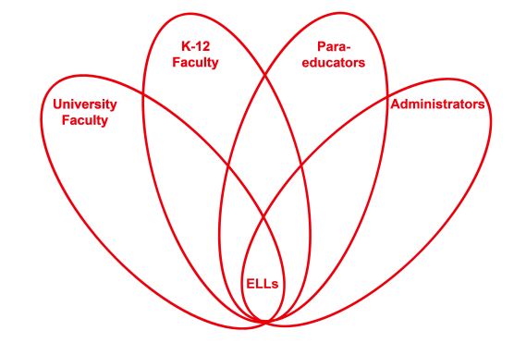

RETELL Strategy Implementation in the Classroom

Teacher | Diane Fortier
Content Area /  Grade Level | Kindergarten
Unit  (Topic or Skill) | Thanksgiving lesson on “Thankful”
Content Objectives | Students will show comprehension of the target word ‘thankful’ by giving a related word or synonym orally and/or using it in a sentence and drawing a matching picture.
Language Objectives | When given a group of people the student will be able to tell when the group is a family and name the members.  Language Objective Differentiation for Proficiency Levels:  Level 1 students can point to family member when asked ‘where is_____?’ as shown a picture of a family.  Student will draw picture of his/her family members.  Level 2 students can answer question ‘Where is ____?’ When shown a picture of a family.  Students draw picture of his/her family and label family members.  Level 3 students can answer question ‘What is the name of the family member that does ____ in the story?’  Student will draw picture of his/her family, label each member and discuss.  Level 4 students can find picture of family member that matches oral description.  Student will draw picture of family and use words and inventive spelling to tell story.  Level 5 students can describe their family using family names.  Student will draw picture of family and string words together to make short sentences to describe his/her family.
Strategy  (Name or Type) | Word Wheel
Brief explanation of how the strategy was used | Word wheel strategy was used in a whole group to expand the understanding of the word ‘thankful’. Extension activities were used during center/lab time. The ‘word wheel’ strategy was used to expand student vocabulary and expose students to a semantic word family for the development of more precise academic terms for oracy and literacy.  Step 1. The word ‘thankful’ was chosen as it had a central role in the meaning of the text.  Step 2. The word ‘thankful’ was put into the center of the wheel. Teacher drew the wheel in front of the students describing the purpose in student language. (This is a way to help us find other words that mean the same as thankful).  Step 3. The book was referenced. The class reread the text taking out the word ‘thankful’ and putting other words in and seeing if the meaning was the same. Students came up with ‘like’, ‘happy’, ‘love’, and ‘special to me’. All words were put in the word wheel.  Step 4. Students were asked if they knew any other words that would mean the same thing as ‘thankful’ and they added ‘love’. Teacher introduced words ‘grateful’ and ‘appreciate’. These words were put in the word wheel as well.  Step 5. Using the book as a guide the class discussed that the children in the book were thankful for people, places and things. They were asked to think about themselves and if they could find things they were thankful for. They had an opportunity to discuss, draw and write about people, places and things they were ‘thankful’ for by rotating through three tables that had large chart paper on them. One table had a chart labeled ‘people’ they were thankful for, one table had a chart labeled ‘ places’ they were thankful for and one table had a chart labeled ‘things’ they were thankful for. As they worked in three groups the adults walked from table to table taking the opportunity to talk, question, and expand the students’ language using their drawing and writing as a guide. The group talked together as they were drawing their ideas. They helped and expanded each other’s thoughts and language. They asked each other questions and commented on their drawings. Adults encouraged them to use language from the word wheel and speak using full sentences. When the activity was complete the class came back together and the groups reported on how they had used the word ‘thankful’. They described what they had talked about and drawn. They used a language stem of “I am thankful (or another word from word wheel) for__________” to express themselves.  Step 6. Extension lab activities included revisiting and discussing the book. Students went to the writing lab center and used a sentence frame to fill out sentence “I am ________ for __________.” Pictures from magazines were available to glue into the sentence form and the word wheel was displayed near the center to reference. Higher level students used the sentence frame ‘I am __________ for__________ because______________.”
Reflection: How and why was the strategy effective? What might you change for next time? | The word ‘thankful’ is a concept that is discussed at Thanksgiving as it is part of the American history. At the younger level this term can be difficult to understand. Replacing the word ‘thankful’ with more common words such as ‘like’, ‘love’, ‘happy’ or ‘special to me’ makes the entire book and concept more easily understood. By providing several different words we were finally able to come up with a cognate that the newcomers could relate to. Teacher took the Level 1/2 into a small group and went back and reviewed the other terms and phrases before they began the writing piece. I brought one Level 1 student down to a Spanish speaking adult to translate the concept to ensure he had the language to explain his thoughts. He did in fact question the woman and ask her for the correct English for what he wanted to say. He returned to the class and rejoined the group, drawing and writing confidently. He shared his work at the share time.  This writing time was very successful for everyone, both in the language that was shared around the tables as well as with the writing the students did. Thinking about other years I have used this book and concept I really feel like we went much more in-depth with the understanding of the concept. The writings and drawing were very appropriate and there were many individual ideas. Other years there would be one idea that everyone just repeated.  The word wheel gave several options for understanding the word. By replacing the word with words the students came up with it created a deeper understanding of the concept. It became more personal for some students. Expanding the lesson and having all students talking, writing and drawing at their level fostered conversation around the topic. Individual ideas were expressed. The students were in a mixed group which helped Level 1 and 2’s be more understood by peers. Students translated for each other. When the students repeated words during the vocabulary time it really increased ELLs’ confidence as they attempted to use the content language.  The second lesson included more practice with using the language to talk about the content. The sentence structures used in the second book were familiar to them after working with the language and sentence stems the day before. This deepened their comprehension of the text and students engaged in questions and comments about what was written.  I would use this technique the first time with a word that has a cognate so the lesson format is understood before attempting this particular concept. I think the strategy is a great way to increase vocabulary and expand thinking. I would keep the group activities the same as these were very effective in enabling the students to talk and use the content language. By the time the students were asked to do independent work, they had had multiple opportunities to listen, speak, draw and write about the topic. It made the independent work much better quality. It was important to use the second book as the ideas in this book were so different from the first book. It gave students a different more global, earth-conscious understanding of the concept of being ‘thankful’.  References used:  Donnelly, W. S. and C. J. Roe. 2010. Using sentence frames to develop academic vocabulary for ELLs. Reading Teacher, 64 (2): 131–136.  Calderón, M. 2011. Teaching reading and comprehension to English learners, K–5: Teaching Reading Comprehension and Content, 67-83. Bloomington, IN: Solution Tree Press.

