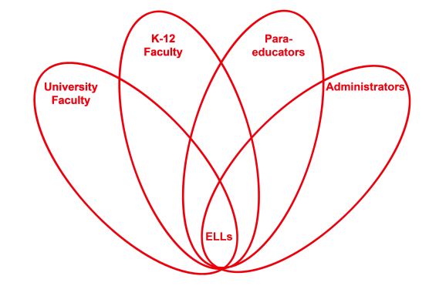

RETELL Strategy Implementation in the Classroom

Teacher | Linda Fiorillo
Content Area /  Grade Level | Social Studies/Kindergarten
Unit  (Topic or Skill) | Thanksgiving-What it means to be “Thankful”
Content Objectives | Students will know the definition of the word “Thankful” and be able to explain what it means to be thankful.
Language Objectives | Students will be able to tell the meaning of the word, “Thankful” and describe ways in which to be thankful.  Language Objective Differentiation for Proficiency Levels:  L1 Students will represent the word, “Thankful” through pictures and use the pictures to describe what Thankful means.  L2 Students will verbally be able to use, “Thankful” in a sentence frame.  L3 Students will be able to research and record alternative words (synonyms) for “thankful”.
Strategy | Word Wheel Strategy
Brief explanation of how the strategy was used | Sheltered Instruction Strategy: Word Wheel  I chose the word, “Thankful”, as the tier 2 word to discuss from the book, Feeling Thankful. I wrote the word on the board encompassed by a circle.  I told the children that they were going to help me make a word wheel for this word and I explained what it was as I put empty circles and spokes around the word “Thankful.”  Next I paired the children and asked them to think about the word “Thankful” and what it meant. They discussed and shared their thoughts with each other.  Next I told the children that they would hear the word many times in the book Feeling Thankful and learn ways to be thankful. I asked them to listen and look carefully because I was going to ask them to tell me what thankful means at the end of the story.  After reading the book, I assigned children to 4 groups to discuss the word “Thankful” and its meaning. They were given markers, chart paper, and books about being thankful. They were to either draw pictures to represent the word or research words in books (with help of adults) and write words and sentences on the chart. Then they needed to compose and complete a sentence frame at the top of their chart with the word that the group generated together.  One group came up with, “We are grateful for…..”  Another group came up with, “We are happy that we have…”  The third group came up with, “We are pleased with…..”  And the last group came up with “We love that we have….”  When the groups completed their group word with pictures and words, we united at the rug and each group held up their chart and reported and explained their word as I wrote each word in the empty circles on the board to complete our word wheel.  We wrapped the lesson up with children volunteering to tell how they were thankful using these words and how they were thankful or showed gratitude or were pleased with or loved what they had etc….
Reflection: How and why was the strategy effective? What might you change for next time? | I felt that this strategy really helped the children to focus on the word and helped them to expand their vocabulary. By brainstorming words that were similar, they could use alternative words as well as the focus word in their conversations and writing. By listening to the read-aloud book, the children got a sense of how the word was used in context and got a sense of what it meant as they heard the word over and over again as it appeared on almost every page of the book. Partner talk and group research and discussions helped the children to gain a thorough understanding of the meaning by giving examples and generating familiar words that were similar to the focus word. Researching the word helped the children to see the word in print for easy recognition. The word wheel was also a nice resource for children to refer to and was a great visual graphic to aid in conversations about the topic.  This strategy helped the children to focus their conversations on a focus word and its meaning. It allowed for children to repeat and practice the word in partners and in small and large groups which got them speaking and listening. The conversations helped children to be exposed to other words that were similar to the focus word and as well as fluent speech. The pictures that some of the children drew, helped cue the children with limited English to express their thoughts about being thankful. Researching the word, helped to expand vocabulary and meaning as they were reading words, looking at pictures and seeing and saying the words in context. Reporting back to the whole group and volunteering to use their new alternative words was a nice assessment to see if they understood the word/s and definition/s.

