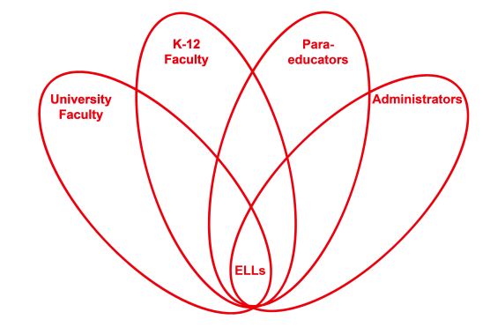

RETELL Strategy Implementation in the Classroom

Teacher | Stacy Sirmaian
Content Area /  Grade Level | Kindergarten
Unit  (Topic or Skill) | Thanksgiving
Content Objectives | ELA Literacy-RF.K.3 Demonstrate basic knowledge of one-to –one letter sound corresponding by producing the primary sound or many of the most frequent sounds for each consonant.  ELA Literacy-RL. K.10 Actively engages in group reading activities with purpose and understanding.  SWBAT state synonyms for the word harvest.
Language Objectives | SWBAT orally generate, within a small group, a synonym for harvest.  Language Objective Differentiation for Proficiency Levels:  Level 1: Students can point to farmers harvesting a field, within given pictures.  Level 2: Students can act out poem about harvesting, using taught gestures.
Strategy | Word Wheel
Brief explanation of how the strategy was used | 1. I explicitly explained to the students the word “harvest” using some aspects of the Seven Step Instruction model.  2. We then created a Word Wheel for the word “harvest” generated by the students. The students worked in small groups to generate words similar to harvest. I helped to prompt their responses through saying sentences where a word could be filled in and through dramatization.  3.I read a poem through pointing out the word “harvest” and discussed the meaning in context.  4. I then engaged my students by using my turn / your turn approach, while having the students act it out using realia.  5. On the third reading, we substituted words that the students generated that were synonyms for the word “harvest”.
Reflection: How and why was the strategy effective? What might you change for next time? | The academic language and discourse happened through the reciting of the poem and partnership discussion centered on the word taught. I know my ELLs really enjoyed saying the poem and substituting the synonym. They also had a great time dramatizing the word harvest and “acting out” using vegetables and fruits as props.  This strategy was a very challenging activity for my ELL students. The next time I need to be better prepared with a variety of sentences and examples to provide them with support and guidance.

