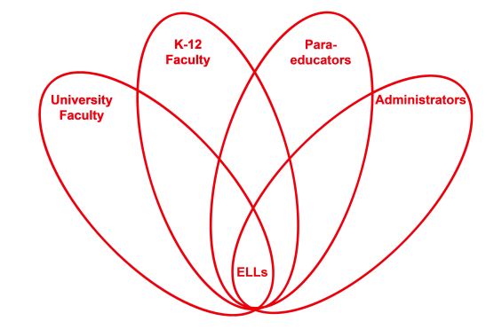

RETELL Strategy Implementation in the Classroom

Teacher | Heidi DeLucia
Content Area /  Grade Level | Kindergarten
Unit  (Topic or Skill) | Harvesting/Farming
Content Objectives | RL.K.10 SWBAT: actively engage in group reading activities for purpose and understanding.
Language Objectives | SWBAT: orally generate, within a small group, a synonym for harvest.  Level 1: Students can point to farmers harvesting a field, within given pictures.  Level 2: Students can act out poem about harvesting, using taught gestures.
Strategy  (Name or Type) | Word Wheel (Harvest)
Brief explanation of how the strategy was used | After reading several books about farming we discussed the word harvest. I introduced the poem “Harvest Time”, having the children echo read and act it out. We then brainstormed synonyms for the word harvest creating our word wheel.
Reflection: How and why was the strategy effective? What might you change for next time? | The children were engaged in the readings and poem however they were limited to a few words which correlated to harvest. We came up with three. We then reread the poem substituting the word harvest with one of the synonyms the children used.

