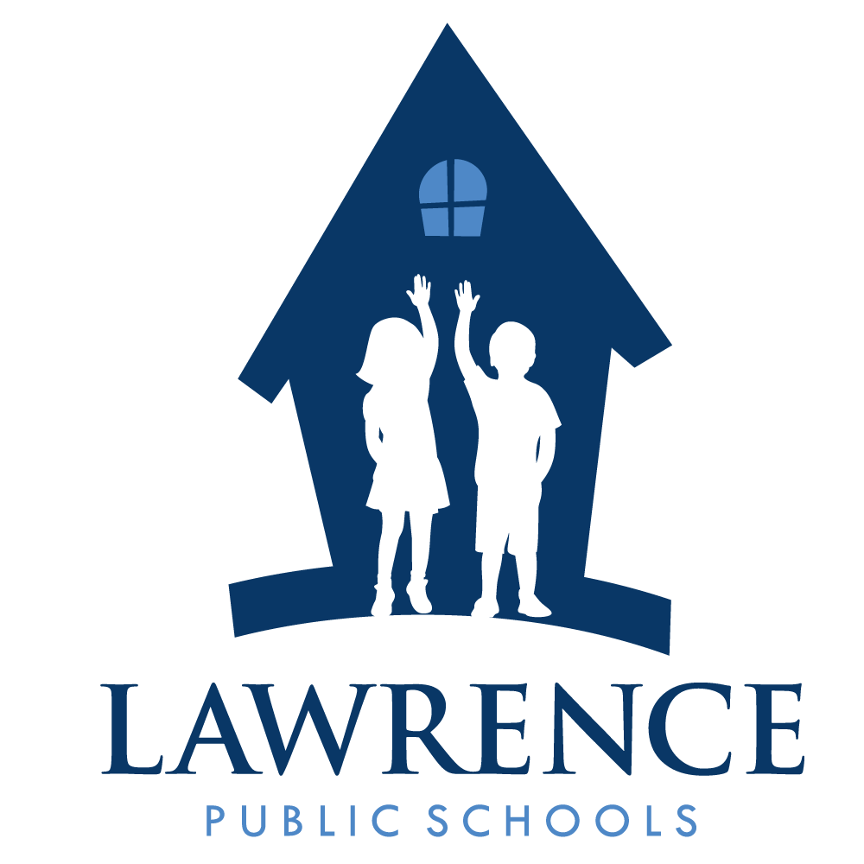
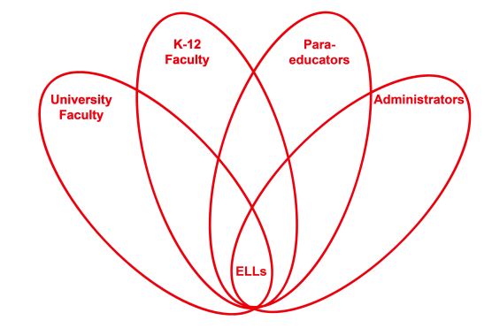

RETELL Strategy Implementation in the Classroom

Teacher | Eileen Lannan
Content Area /  Grade Level | ReadingELA - 8th grade
Unit  (Topic or Skill) | Civil Rights – Montgomery Bus Boycott
Content Objectives | Students will understand the impact average individuals can have on important public policy issues in the U.S.
Language Objectives | Students will expand their vocabulary by developing word families using synonyms.  Level 3 - Students will work with a partner to brainstorm synonyms for prejudice, segregation and integration, and report out, orally.  Level 4 – Students will complete the word wheel using the internet and/or thesaurus and write their responses on index cards and report out orally.
Strategy  (Name or Type) | Word Wheels
Brief explanation of how the strategy was used | Word Wheel (Vocab) Using the vocabulary word, find as many synonyms as you can.  Word Wheel – Prejudice, Segregation & Integration  Prejudice: dislike, hate, injustice, unfairness, intolerance, bigotry, bias, unequal treatment, discrimination.  Segregation: Separate, isolate, apart, not together, spaced out, excluded.  Integration: add, combine, mix, put together, incorporate, join.
Reflection: How and why was the strategy effective? What might you change for next time? | Taking time to analyze important words is critical to overall understanding of text. This strategy helped make words understandable by finding smaller words that are related or mean the same thing. The ELLs are seeing the words, hearing the words, talking about the words, and writing the words. This strategy of finding synonyms or related words for the vocabulary made the content comprehensible because the words directly relate to the theme of the social justice unit. There are more words to be studied, but this is a good start. This word wheel strategy helped the ELL’s to become familiar with three important vocabulary words and other words that were not necessarily vocabulary words, but in the word family. The synonyms made it easier to understand the vocabulary words. In addition, the strategy got everyone brainstorming synonyms. It was fun for the ELLs. The more enthusiastic the teacher is, the more fun it becomes for the students. It got a little competitive and some ran to get dictionaries and thesauruses’ to be the first to find some similar word. Sometimes the lower level ELLs allow the higher level ELLs to do their work for them. I know they have to rely on each other a lot, but next time I would like to see the lower level ELLs take a more active role in their learning. I think I would raise expectations for all ELLs.

**See materials and resources on the following pages.**

Word Wheel Example: Below

isolate

Segregate
Segregation

Apart

Separate

