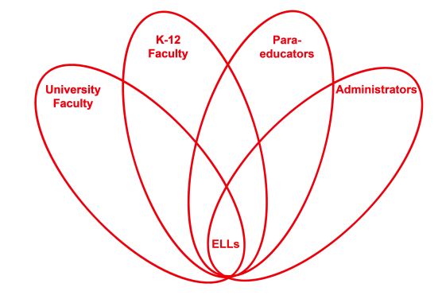

RETELL Strategy Implementation in the Classroom

Teacher | Carlene Hackett
Content Area /  Grade Level | Reading/Social Studies/Grade 4
Unit | Westward Expansion with Mentor Text
Content Objectives | Determine the meaning of words and phrases as they are used in a text, including those that allude to significant characters.
Language Objectives | SWBAT use sentences frames to demonstrate their understanding of new words from the text, Little House on the Prairie.
Strategy | Word Wheel
Brief explanation of how the strategy was used | Whole class Read Aloud  Mentor Text: Little House on the Prairie; chapter 9  The whole class has been reading Little House and studying Westward Expansion. As a class we have been working on building and understanding vocabulary throughout this book.  Vocabulary was frontloaded as seen in the Tiered words below.  I read the chapter aloud to the class. I used the word wheel strategy before reading the text to help them comprehend the word before reading it in the text.  Students will practice using the word “splendid” using sentences frames.  Sentence frames:  L2: It was a ___________ day due to the sun shining.  L3: It was a ______________ day due to the sun shining which made it __________.  Tier 1 Tier 2 Tier 3  House fiddle Prairie  Build pounce creek
Reflection: How and why was the strategy effective? What might you change for next time? | It went well; the strategy is used in a vocabulary notebook to help them build on their vocabulary. It is more effective if the words are posted in the classroom, maybe even an example of the word wheel. This word comes up several times in this text.  Example:  magnificent  glorious----- Splendid-------elegant  gorgeous  - Identify the word “splendid” from the text.  - As a class we located 3 other synonyms for the word “splendid” using a dictionary and thesaurus.  I listed the words on the board using a word wheel; students will make their own word wheel in their vocabulary notebook.

