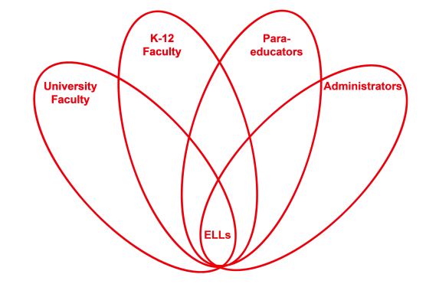

RETELL Strategy Implementation in the Classroom

Teacher | Melissa Carter
Content Area /  Grade Level | Health/ Gr.3
Unit | Emotional Effects of Bullying
Content Objectives | Students will be able to identify the feelings a victim may have after being bullied.
Language Objectives | CCSS.ELA-Literacy.L.3.5b Identify real-life connections between words and their use (e.g., describe people who are friendly or helpful).  Students will be able to create a list of feelings a victim has when he or she is bullied using a word wheel.  Language Objective Differentiation for Proficiency Levels:  Level 1 & 2  Students will be able to make a list of feelings using a picture word bank with a partner to add to a word wheel.
Strategy | Word Wheel
Brief explanation of how the strategy was used | -Review what bullying is through think, pair, and share  -State that today’s goal is to identify how the victim feels after being bullied.  -Use mimio to project large class word wheel with feelings or emotions as your centerpiece  -Model through think aloud picture walk of previously read story of “Bullies Never Win” by Margery Cuyler that today we are going to be detectives looking for how Jessica, the victim feels. As a detective I noticed throughout the story that Jessica is described as being “worried” repeatedly. I am going to add that previously taught vocabulary word to my feelings word wheel.  -Reread story and have students with a partner act as detectives on the lookout for other feelings to add to their word wheels.  -Share their feeling words to add to class word wheel chart displayed by the mimio.
Reflection: How and why was the strategy effective? What might you change for next time? | The ELLs in my class were able to engage in the content because the word wheel gave them the ability to focus on the theme of feelings. They were able to relate the visuals of the victim’s feelings in the story to the picture word bank that they had in front of them. Then they were able to add those feelings to the wheel. The strategy of a word wheel with a partner made it easier for my ELLs to discuss the feelings that they saw in the story. They were more willing to participate in sharing the feelings that they noticed to add to the class word wheel because they were actively involved in the lesson.  The next time I try this strategy, I would have them draw facial expressions with the words that they used for the word wheel of feelings. I also would expand the word wheel into using it for synonyms for previously taught feelings such as for the word worried. I would have worried be in the middle with words such as nervous, anxious, scared, uptight, troubled, fearful and distraught surrounding it. I would present those to the students as other examples of that word.

