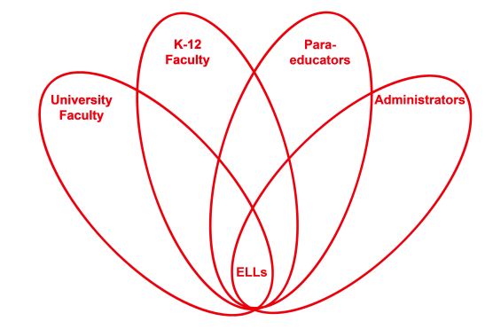

RETELL Strategy Implementation in the Classroom

Teacher | Andrew Larocque
Content Area /  Grade Level | Algebra 1/ Grade 9
Unit  (Topic or Skill) | CME: Algebra 1 Common Core  Review vocabulary before midterm
Content Objectives | SWBAT:  - Review Chapters 1 through 4 for midterm  - Work on and discuss the practice midterm
Language Objectives | - Students will read and analyze the text asking questions to study for midterm.  - Students will write vocabulary words as a review for the midterm.
Strategy | Content Vocabulary Roundtable
Brief explanation of how the strategy was used | The content vocabulary roundtable made the students self-aware of the vocabulary they know and should know about the math content. The students were also able to review the text for vocabulary and content that they had learned from the first semester of Algebra 1. The first round allowed the students to have the opportunity to do a self analysis of how much they knew without looking at the text. The second round gave the students a chance to read and examine the text book for specific vocabulary words they knew they should know but needed a refresher to remember. The third and final round where the students had to remember and speak using the vocabulary, was just another opportunity to review different vocabulary words. The amount of words increased from round one to two and the words became more content specific. This showed me that the students were actually using the text and comprehending the content better because they could recall more specific vocabulary.  The content vocabulary roundtable was played as a game which caused more students to be engaged than if I gave the students a vocabulary sheet because the students wanted to be the team with the most words after the three rounds. I feel if it was an individual activity where I told the students to write as many words as possible, it would not have been as successful. This is because each student only had to write one word at a time which seemed to lower their anxiety because there was enough time to think of a vocabulary word, write it down, and think of another word.
Reflection: How and why was the strategy effective? What might you change for next time? | The strategy helped students recall academic language that they already knew without reviewing the text. Then it had the students write down those vocabulary words. The students were then able to read the text book to find more vocabulary and concepts. After putting the text book away, the students were able to write the words they remembered in the following round. The third round gave the students the chance to speak using the words. They had to listen to their peers and say a vocabulary word that was not used. This gave the ELLs in the classroom a chance to write, read, listen, and speak using the content vocabulary words. This strategy allowed the use of the academic language in all four domains.  Next time I may change the strategy by creating another round where each team is given a list of definitions and has to write the word that belongs to the definition. This would help in the review process because after writing the words twice, they should know the definitions. Having the students attach the words to the definition would cause the students to have a better understanding of the use of the word improving both the content knowledge and the academic language of the students. I would then do the speaking round last.

