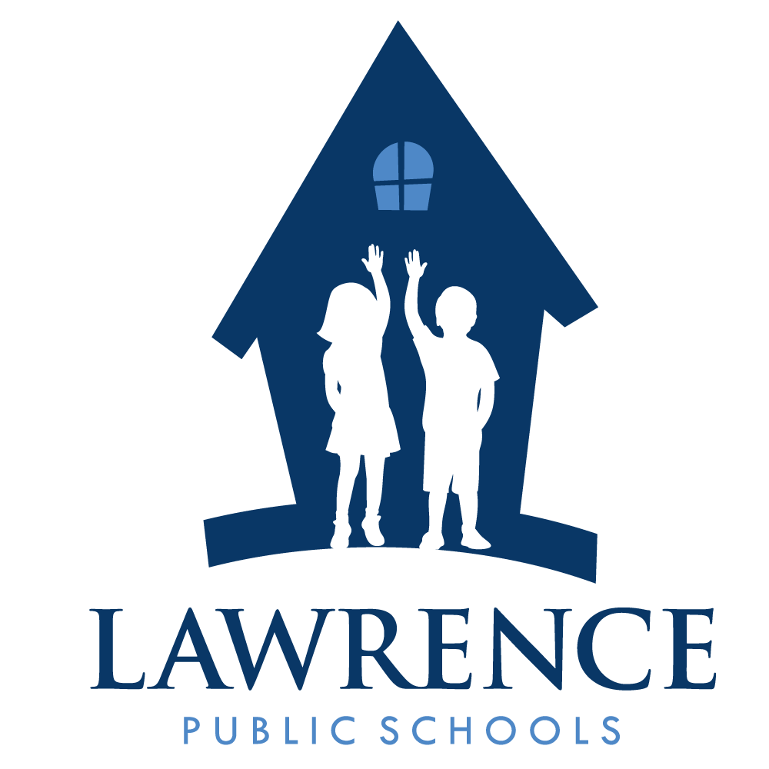
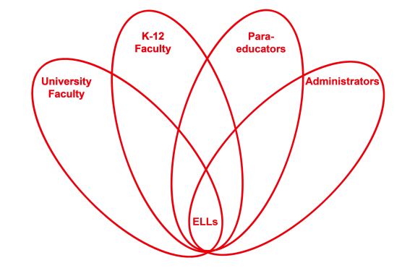

RETELL Strategy Implementation in the Classroom

Teacher | Carolyn Driscoll
Content Area /  Grade Level | ELA Grade 4
Unit | Westward Expansion
Content Objectives | Students will be able to cite evidence from the text to explain the challenges faced by the pioneers moving west during the 1800’s. This will be done by creating word banks with their partners.
Language Objectives | Students will be able to orally discuss and write about the challenges faced by the pioneers as they moved west.  Language Objective Differentiation for Proficiency Levels:  Levels 2 and 3 will be placed in groups with native English speakers or higher- level ELLs. I will circulate to check in with Levels 2 and 3.  Levels 2 and 3 will have sentence frames to help them formulate their responses for the writing activity that comes after the pre-writing activity of the Content Vocabulary Roundtable.
Strategy | Content Vocabulary Roundtable
Brief explanation of how the strategy was used | Lesson Sequence:  Students have been reading a variety of texts on Westward Expansion. This week they have been reading from the text “The Journey West” by Marc Gave. Students were placed in groups of four to five students each. They were then paired up with another child as their partner. For this lesson they read pages 8 to 9 of the text with their partner. This section was entitled “Getting There” and it describes the hardships faced by the pioneers as they traveled west. As a pre-writing activity I explained to students that after they read these two short pages they would be asked to think about words from the text that would help them answer the following prompt that I had written on the board: “Describe the challenges faced by the pioneers as they traveled west.”  I explained that they would be creating a word bank that would help them formulate their response. I then instructed them to read these pages with their partners. Then the first person in each group wrote down one word from the text and passed it to the person in their group on their left. This person wrote down a different word and they continued to pass the paper along until all four or five students in the group had participated. I had groups count the words and record the number of words they had written. I had each group read their list of words in their groups. Then students reread the pages with their partners and went through another round of Content Vocabulary Roundtable. They counted up the words again. I had a large Post-It note on the board and I called on students to tell me one word they had written and we created a class word bank. The students were then instructed to begin thinking about the prompt they needed to respond to. The level 2 and 3 ELLs had sentence frames to help them formulate their responses and I checked in with them to give immediate feedback. My other ELLs were able to use the words from the word bank, as well as the text, to write a response to the prompt that was organized and met the criteria from the rubric.
Reflection: How and why was the strategy effective? What might you change for next time? | The roundtable was a great way for students to read, write, listen and discuss content vocabulary words that would help them to understand the content being taught. The reading portion involved two brief pages that had lots of vocabulary for them to draw upon to answer their prompt. They were exposed to new vocabulary words, which they can now use in future writing assignments as well as in classroom discussions. Working in small groups was less stressful for my ELLs and I believe it made them more eager to participate in this activity. This activity involved reading, listening, discussing and writing about the academic language I wanted them to learn to help them understand the content objective. I feel this activity helped expose my ELLs to new vocabulary words and I feel they are more confident using these new words in their writing because of this activity. Orally discussing words with partners was very helpful to my ELLs.

