Vocabulary Development: Creative Word Walls, Floors, and Windows
by Timothy McCarron, Principal Math, Science and Technology High School
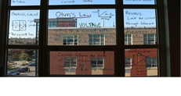
Conventional Word Walls are a solid instructional practice that can benefit vocabulary development for all students. The RETELL initiative promotes the use of Word Walls as an essential practice for helping ELL students increase their working vocabulary. In some classrooms at MST, teacher creativity has taken Word Walls and turned them into Word Windows and Word Floors.
Word Windows in MST contain vocabulary terms, equations and even theorems that are written in large print on classroom windows. They are easily accessible for students to view and use as a reference when they are in the classroom. Word Windows can also be quickly used by the teacher during his/her instruction as a reference, thus providing repeated exposure to terms, equations and theorems, which promotes learning and academic language development.

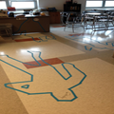
Word Floors are used in some of our ELA classrooms to enhance literacy instruction. Characters from literature and some of the major themes of the novel are “taped” out on the classroom floor in silhouette form. Vocabulary in context and other important concepts are then placed within the silhouette of the novel’s main characters or themes. The entire classroom comes alive with the themes/characters of the novel seen throughout the room. Various forms of interactive instruction are made available to students using this technique.
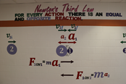
Word Windows and Floors are not meant to take the place of traditional word walls. However, they can exist as a complement to traditional word walls. The combination of using a variety of word walls has the potential to enhance academic language across the content areas.

