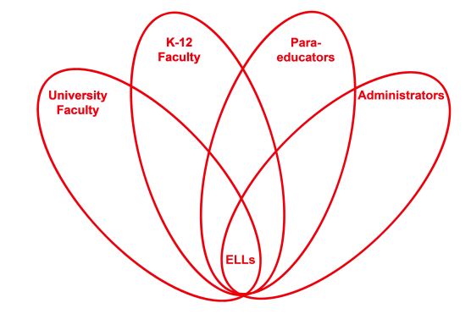

RETELL Strategy Implementation in the Classroom

Teacher | Eileen Lannan
Content Area /  Grade Level | Reading/ELA Grade 8
Unit  (Topic or Skill) | Civil rights – Montgomery Bus Boycott
Content Objectives | Students will be able to explain what led up to the Montgomery Bus Boycott.
Language Objectives | Students will improve reading comprehension and discourse through the use of the think-aloud strategy.  Level 3 - The student will observe the teacher and his/her partner practicing the think-aloud technique. Student will offer answers to teacher’s questions.  Level 4 – The student will practice the think-aloud technique by asking appropriate questions aloud and answering the question aloud.
Strategy  (Name or Type) | Think–Aloud Strategy (through questioning)
Brief explanation of how the strategy was used | A good reader adopts strategies that help him/her to understand or comprehend what they are reading. The think-aloud strategy is one of these strategies. Think-alouds have been described as a teacher’s way of ‘eavesdropping on someone’s thinking.’ Teachers model this strategy by verbalizing aloud while reading a selection orally. Their verbalizations include describing things they're doing as they read to monitor their comprehension. The purpose of this think-aloud strategy is to model for students how skilled readers construct meaning from a text. For students, think aloud questions will help them understand more from their reading and understand more about how they read. Below are examples of questions to support thinking aloud;  - What do I know about this topic?  - What do I think I will learn about this topic?  - Do I understand what I just read?  - Do I have a clear picture in my head about this information?  - Can I form a mental image in my head?  - What more can I do to understand this?  - What were the most important points in this reading?  - What new information did I learn?  - How does it fit in with what I already know?  - Where have I heard it?  - What does it remind me of?  - What questions do I have about it?  Give students opportunities to practice the technique, and offer structured feedback to students. Demonstrate how good readers monitor their understanding by rereading a sentence, reading ahead to clarify, and looking for context clues. Students then learn to offer answers to the questions as the teacher leads the Think Aloud.
Reflection: How and why was the strategy effective? What might you change for next time? | This think-aloud strategy helped my readers to comprehend more easily what was being read. It was used to increase student comprehension and independence. The students verbalized their thoughts and thus, brought into the open, the strategies they were using to understand the text. Students were learning to question themselves during their reading and be consistently formulating questions. Through the interactions (discussions) that the think- aloud promotes, a better understanding of the text emerged. It is in this way that students were learning to monitor their own comprehension. This strategy was very useful because students were verbalizing all their thoughts in order to understand the reading. These thoughts might include commenting on or questioning the text, bringing in their prior knowledge, or making inferences or predictions. These comments revealed student weaknesses as well as their strengths for comprehending and allowed me, the teacher, to assess their needs and plan for more effective instruction.  The think- aloud strategy promoted much teacher – student interaction because we were working together to construct understanding of text. The think-aloud required students to ‘report out’ their thoughts while reading so there was a lot of academic language (discourse) in the process. The discourse allowed us to talk about the text and make connections between prior knowledge and the text. The content of the book is very high interest, so discourse about the text was easy. The students love this unit of study so discourse and dialogue using academic language seems to be the natural course. For many, the questions they verbalized were of a much higher level than I expected. The long term benefit of the think-aloud strategy is that the student will gradually learn to internalize the dialogue and it will eventually become their inner speech.  The next time I try this strategy, I would not ask a level 3 ELL to formulate questions. I had no intention of asking my level three ELL to do anything but observe. But, then I thought that maybe we would give it a try. It seemed easy enough. No, he had no idea what the right question to ask was or at what time to ask it. He was so super focused on decoding the text, he could not for the life of him ask a question that related to the text. He just looked as though he had never done it before. The strategy was not new to any of my regular students, even though we have not used it this year. This strategy is not a part of my regular teaching. Nonetheless, my students are very familiar with it, so someone taught it to them. My guess would be an elementary teacher. Some were rusty, but knew what to do and how to question what you read. I was definitely impressed by some. But in the future, I would be very careful with ELLs and better plan a good time to introduce new strategies. They need much more time given to observing the technique in action so lots of modeling over a longer period of time. (check √, lesson learned).

