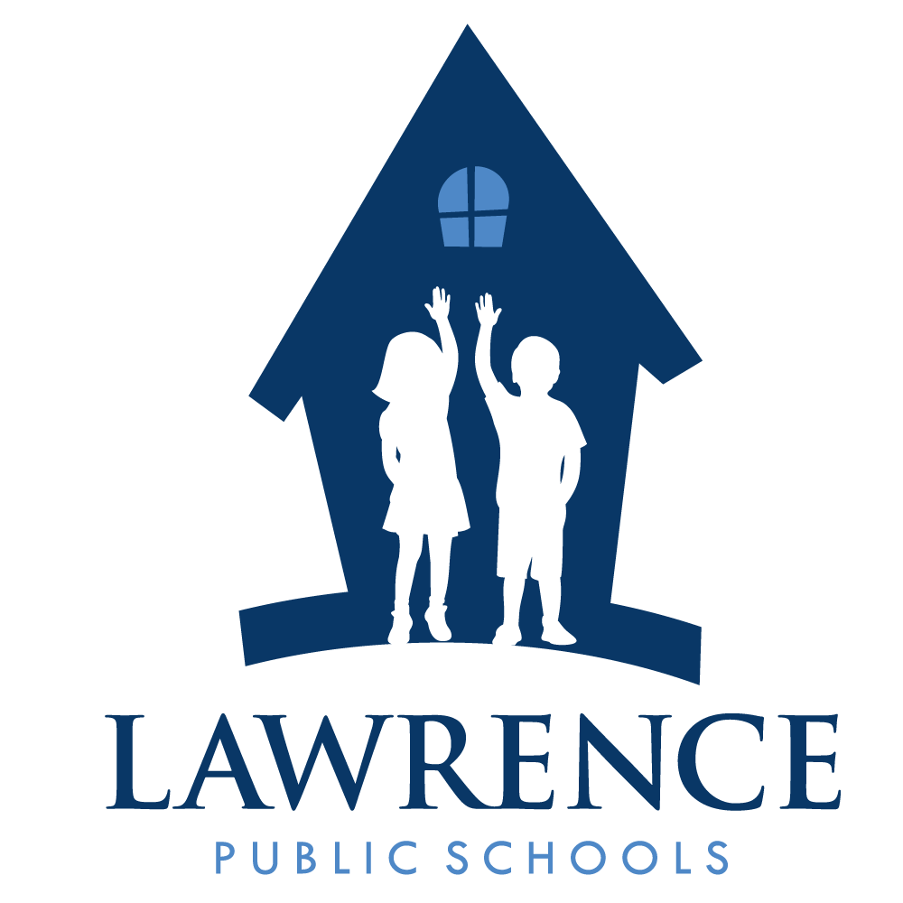
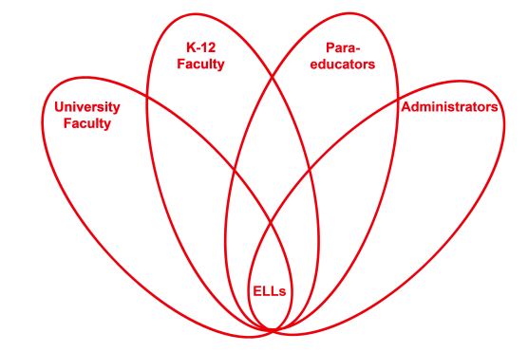

RETELL Strategy Implementation in the Classroom

Teacher | Linda Fiorillo
Content Area /  Grade Level | ELA/Kindergarten
Unit  (Topic or Skill) | Poetry
Content Objectives | Students will be able to create mental images in their minds by connecting prior knowledge with text from poetry.
Language Objectives | Students will be able to describe images that they think about as they read a poem.  Language Objective Differentiation for Proficiency Levels:  L1 Students will listen to a poem and express their thoughts  and images in their minds through illustrations.  L2 Students will listen to a poem and use a detailed sentence  to orally describe a mental image in their mind as they  connect to poetry and their own thoughts.  L3 Students will listen to a poem and write a sentence to  express a thought that connects to the poem
Strategy | Think Aloud
Brief explanation of how the strategy was used | - Introduction: I reviewed the lesson objectives with the students.  - Next, I introduced tier 2 and 3 vocabulary to enhance comprehension of the poem. Some words were embarrassed, bowed, removed, stage, concert  - Next, I asked the children if they ever attended a concert or show and told them to turn to a partner and share their experiences.  - After students shared, I explained that the poem that I was going to read was about a Kindergarten concert. As I read, I would pause periodically and point to my head to show them I was thinking and I would say, “Hmm…I picture….” and explain step by step what I pictured in my mind. I continued to read, repeating this procedure.  - A few lines later, I stopped and asked the children to close their eyes and make a mental movie/image in their minds.  - After ample time, I asked them to turn to a partner and share their thinking about the text of the poem and what it reminded them of and the picture that it made them think of in their mind.  - When the poem was finished, I asked the children to go to the tables and draw and/and or write about their visual images.  - When we united, children orally shared by showing, telling, or reading about their pictures/words.  - We concluded by saying, “Good Readers can make images in their minds as they read books and poems.”  - The students were then sent to read their independent readers and were encouraged to use this strategy as they read.
Reflection: How and why was the strategy effective? What might you change for next time? | Modeling the strategy helped the children know how to access their prior knowledge as they watched and listened to how the teacher connected to the text and her explanations of her personal experiences. Also they had clear expectations as to how to create a mental image and what to do when it came to their turn to practice the strategy.  This was a fun strategy. I liked pretending to think and talk out loud. I was a bit silly and the children seemed to listen more when I acted this way. This strategy allowed the children to listen to fluent language, and to orally practice the strategies with a partner. By drawing (representation of thought) and writing about their images, they were actively involved and might be able to retain the concept more because they may remember their pictures and words as they described their images. The activities helped to enhance their thinking about the strategies and to improve their reading. This exercise helped the children to better understand the poem as they could interact with it as they developed their mental images.  The next time I try this strategy, I was thinking that I could make little “thinking caps” that children could put on their heads as we create mental images in our minds as we read. I could put a question mark in a little cloud that would be displayed in the front of the hat. This might get them excited about the activity and encourage them to utilize the strategy. Also, I think it would be a good idea to make an anchor chart next time so that I could put it up in the library area for children to refer to as they read in the classroom.

