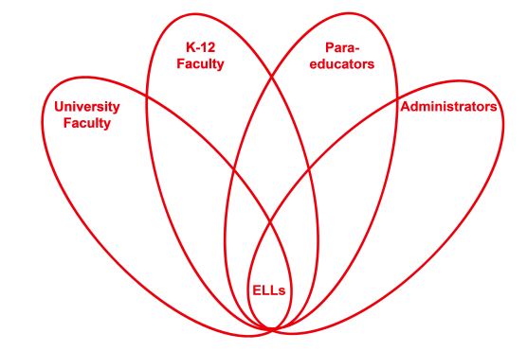

RETELL Strategy Implementation in the Classroom

Teacher | Andrew Larocque
Content Area /  Grade Level | Algebra 1/Grade 9
Unit  (Topic or Skill) | CME: Algebra 1 Common Core  Problems 2 through 4 from lesson 4.03 Rates of Change, which is the 3 lesson of investigation 4A All about Slope, which is the first investigation of Chapter 4 Lines
Content Objectives | SWBAT:  - Recognize slope as a rate of change  - Calculate the average speed between two points on a distance-time graph
Language Objectives | Students will orally and in writing explain that slope is average speed between two points on a distance-time graph.
Strategy | Think Aloud
Brief explanation of how the strategy was used | I did a think aloud for questions 2 through 4 which were questions to a story problem. The story was about driving on a toll road. The toll road had certain criteria. This was the criteria stated for the toll road: A toll ticket shows your location and the time that you entered a toll road. The toll is 3 cents per mile. A toll-taker charges an extra $100 if your average speed is between 65 mi/h and 80 mi/h. A toll-taker charges an extra $200 if your average speed is more than 80mi/h. There is necessary information and extra information that the students do not actually need.  Question 2 states Tanner enters a toll road at 3pm. He leaves the toll road at 6:30pm. He travels 200 miles. What is the toll for the distance he travels? What is his average speed? Is there an extra charge?  Question 3 states Tanner travels home on a toll road from 10am to 1pm. He travels 200 miles. What is the toll for the distance he travels? What is his average speed? Is there an extra charge? Tanner does not want to pay an extra charge. What is the shortest time that he could travel on a toll road?  Question 4 states Kristin travels a toll road for 120 miles. After 70 miles, she notices that she has traveled for one hour. How fast should Kristin drive for the rest of the trip to avoid an extra charge? Sketch a distance-time graph for Kristin’s trip.  Before reading the story problem I asked the class to define a toll road. Once the discussion was over, I read the whole story problem really quickly and came to the questions and said, “Wait, I don’t remember what I read, let me go back and read slowly.” I did this to show that even I, the teacher, have to reread sometimes. Once I read the story again, I came to question 2. I said aloud, “He traveled 200 miles how much does Tanner have to pay? Oh I remember it stated 3 cents per mile. How do I write that as a decimal number? Oh yeah, 0.03. I need to now multiply that by 200. I get 6, meaning he owes $6.” Too often, students read 3 cents and forget to write it as a 0.03. The next part of the question relates to the content objective because slope is average speed which is change in distance divided by change in time. I read the second part of the question aloud and said, “What do I know about average speed?” I wrote on the board, slope = avg speed = change distance/change time. Then I said, “Tanner traveled 200 miles but it didn’t tell me exactly how long. It stated that Tanner started at 3pm to 6:30pm. That is how many hours? That is 3.5 hours.” I wrote 200/3.5 approximately equals 57 mi/h. Excitedly I said, “Tanner doesn’t have to pay an extra charge because it is less than the 65 mi/h”. Then I went onto question 3 and did the same for the first part of the question as I did for question 2 because they were the exact same question with the same steps. When it came to the second part of question 3, I said, “Tanner travels from 10am until 1pm. If I subtract those numbers it doesn’t make any sense because 1-10=-9. What do I do? Using my fingers it equals 3 hours. I could rewrite 1pm as 13 and then it works because 13-10=3.” Then I write on the board 200/3=66 and say with a sadness in my voice, “This means he travels 66mi/h so he will have to pay an extra charge.” The next part of the question asked what is the shortest time for Tanner without paying an extra charge, so I continue doing the think aloud plugging in 64 mi/h for the average speed and solving for the time. For question 4 as part of my think aloud I explain that I do not know how to figure out how fast Kristin should drive for the rest of the trip to avoid an extra charge but I do know how to sketch the graph. I sketch the graph and then explain how I use it to answer the first part of the question and find average speed so Kristin does not have an extra charge.  This story problem gives a real life example showing that average speed relates to slope. The issue is that there is a lot of reading and information. There are multi-level questions going from basic understanding to inferring. The think aloud shows students how to tackle each level of question step by step. It also showed the student how the slope is the same as average speed. During the think aloud the students observed how I handled arithmetic thoughts, conceptual thoughts, and how to fix mistakes that I feel students would have made. This strategy allows the students to actively see me as the problem solver handling and how to approach this type of math problem.
Reflection: How and why was the strategy effective? What might you change for next time? | The think aloud strategy allows the students to observe how to handle and deal with the academic language within the math problem. The story problem about driving on a toll road really was not important; however it did give us the premise in which to have criteria to do the math. It showed how to dissect the academic language into information that was necessary and the thought process in dealing with that information. For example, ELLs see 3 cents and do not realize they need to change that to 0.03. When subtracting 3pm from 6:30pm it is 3.5 hours but trying to do the same with 1pm and 10am does not exactly work using the same method. The students were able to observe how I handle the difference between the two situations. In question 3 I had to figure out how Tanner would not have to pay an extra charge and the students watched and heard how I solved that using the criteria given. They also observed me analyzing the academic language of the text book and changing it into mathematics. They even saw in question 4 that I skipped the first part and went right to the sketch and could hear my logic on why I made that decision. The think aloud allows me to model the correct use of academic language and the correct use of mathematics.  Next time I would change the strategy by having students go through the story problem and questions 2 through 4 and write down all the questions they could come up with and then use that for my think aloud. This way my think aloud would address all the questions and be tailored to answer their questions. The students could also compare the way I thought about answering the questions with their internal monologue. This would make the think aloud more engaging because the students would be the ones preparing my think aloud questions which I would model how to answer.

