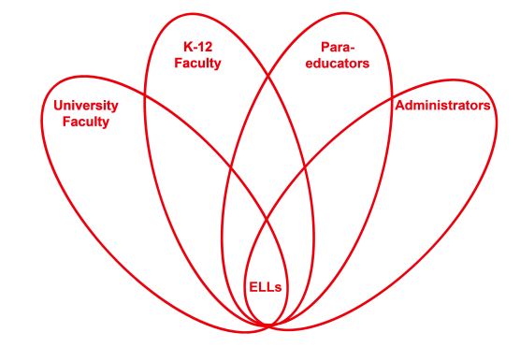

RETELL Strategy Implementation in the Classroom

Teacher | Joshua Segaloff
Content Area /  Grade Level | Science Middle School Grade 7
Unit  (Topic or Skill) | reading comprehension
Content Objectives | Students will be able to use a think aloud to make text-to-self connections.
Language Objectives | Students will speak a think aloud and compare through writing an experience of a character in a text to his/her own life.  WIDA levels 1-3 Students will be able to identify particular elements of non-fiction  WIDA levels 4-5 Students will be able to identify specific informational texts
Strategy | Think Aloud
Brief explanation of how the strategy was used | When I modeled my think aloud, slowly, and using both drama and video clips, I was able to help build background information for my students. By using visuals to go along with my thoughts, I was able to see how helpful this process was for my students who were able to understand some of the text when I modeled it.  Connection: Yesterday we learned that good readers use their schema to make text to-self connections as they read. Today, I’m going to continue to model how to make text-to-self connections as I read.  Explicit Instruction (Show them exactly how to do it): Read and think aloud while they watch. Today I am going to read the book Cockatoos. I will read and then think aloud to show you how I make connections. Remember when I have my book up like this I am reading. When I have my book on my lap, I am thinking aloud. I will stop after the sixth page and talk about how I got tired of having teachers refer to me as “David Smith’s little sister.” Then, I will stop after Professor Dupont looks in the attic for his cockatoos. I will talk about playing hide and seek with my brother when we were little.  Guided Practice (Ask them to try it with you or with a partner.) I will stop after Professor Dupont goes down the cellar to look for his cockatoos. I will say, “at this time, I’d like you to turn and talk” with the person sitting next to you. I’d like you to discuss by using a “think aloud” text-to-self connection you have just made using your schema.  Send Off for Independent Practice: Today as you read your non- fiction text, I would like you to complete the first three pages of your non-fiction flip book.  Group Share: Today you are going to continue to practice independent reading. Remember to use schema as you are reading to make text-to-self connections.
Reflection: How and why was the strategy effective? What might you change for next time? | This strategy worked well when modeled and when it contained the use of humor. Students were eager to demonstrate their own think alouds and were given questions to ask their partners. This led to positive discussion that included academic language. Next time, I’d use think alouds when previewing the story and to introduce tier 2 and tier 3 words. I might ask questions about how to figure out genre, author, and who might be the audience. By modeling this technique I can get my students to begin to think about the importance of author’s purpose.

