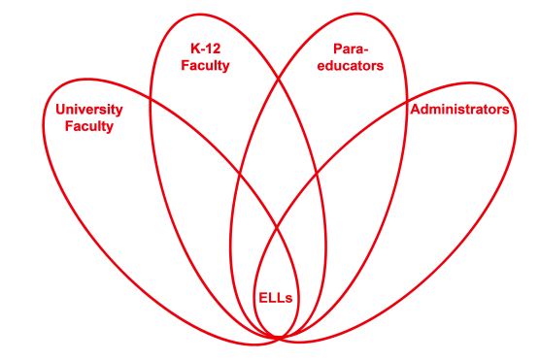

RETELL Strategy Implementation in the Classroom

Teacher | Paul Flanigan
Content Area /  Grade Level | Language Arts Grade 5
Unit  (Topic or Skill) | Wringer by Jerry Spinelli  Compare/Contrast
Content Objectives | The students will be able to compare the two visions of the birthday party.
Language Objectives | The students will discuss the difference between the main character and his mother’s view of the birthday party.
Strategy | Think Aloud
Brief explanation of how the strategy was used | We were reading a section of the story where the main character and his mother were discussing their individual ideas of his birthday party. My thinking was of how his mother envisioned the party. I asked the students to compare that with what the character wanted.
Reflection: How and why was the strategy effective? What might you change for next time? | The strategy was effective because it presented ideas that were in the book but were not clearly spelled out. The Think Aloud focused those thoughts for the students so that they could better understand them.  The next time I try this strategy, I would continue to present the mother’s point of view throughout the story. This would be important because it is an underlying theme throughout the story. The main character is growing up and starting to go against the wishes of his mother.  I would also like to use this same technique to present the ideas of other characters within the story. I feel by portraying those roles I can put the students in the role of the main character. They will begin to think as he does and make connections to him. All of this will help them better understand his thoughts as he progresses through the story.

