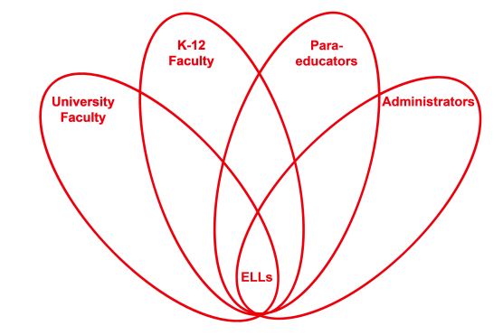

RETELL Strategy Implementation in the Classroom

Teacher | Carolyn Driscoll
Content Area /  Grade Level | ELA Grade 4
Unit | Holocaust/WWII
Content Objectives | 4RL1  I can use details and examples in a text to explain and draw inferences.
Language Objectives | I can cite details and examples in the text when making inferences to increase my comprehension.  Language Objective Differentiation for Proficiency Levels:  Some of my ELLs will orally cite details and examples from the text after I stop to discuss what I am thinking and after I ask them what they are thinking. Before orally citing evidence they will discuss what they are thinking with their partners. Others will write about the details, after partner discussion, to help with their comprehension of the text.
Strategy  (Name or Type) | Think Aloud using “Lily’s Crossing”  I will verbalize my thoughts aloud while reading sections of the text orally to the students. I will model the process of comprehension. I will also pay attention to specific details in the text.
Brief explanation of how the strategy was used | Lesson Sequence:  Chapter 18 in Lily’s Crossing  I frontloaded vocabulary to students (10 mins).  Then, as I began my lesson, I explained to my students that although they have heard me do think alouds in the past I was going to do even more during today’s lesson. I was going to share how my thinking aloud and paying attention to specific details will help me comprehend the text better. As I read the second paragraph, the line read, “Lily could feel the perspiration running down her back.” I stopped and said, ”Hmm…perspiration...I think that happens when people perspire which means they are sweating… I’m thinking people perspire/sweat when they are hot or sometimes when they are nervous about something. I think here Lily is really hot because in Chapter 17 we talked about the heat and how stifling it was so I think Lily’s hot here. I continued various think alouds as I continued reading Chapter 18. When Albert was talking about the “palacsintas” his grandmother packed for him before he left Hungary “Lily knew he was about to cry but she couldn’t think of what to say.” I did another think aloud here where I talked about why Lily thought Albert was about to cry. I made connections to why people cry: they are sad, they miss a loved one, etc. I modeled my thinking to infer that I believed Albert was about to cry because he missed his “Nagymama”(grandmother) because she had been so kind to him to help him prepare for his journey from Hungary. I brought up prior text evidence/connections in the text to support this think aloud. As the lesson continued I stopped after reading Lily tell Albert, “If you want to learn, it’ll be faster in the bay. And that’s my final offer.” (By this point in the story we have discussed why Albert wants Lily to teach him how to swim and they have been bickering back and forth about it). To engage my ELLs and the rest of my class in discussion at this point I ask, “What do you think Lily means by ‘my final offer’?” ELLs think about and discuss this with their partners. Others write down what they are thinking after discussing with their partners. We share out on the rug.
Reflection: How and why was the strategy effective? What might you change for next time? | Using think alouds helped to make the content comprehensible for my ELLs because they were able to see how I stopped periodically throughout the text and evaluated whether or not I understood what was happening in the text. I stopped when I wasn’t quite clear on a particular word/phrase in the text. I stopped when I wondered why a character was doing something or what they were thinking. As I made connections to previous details/ideas in the text I was able to help my ELLs make better sense of what was happening in the story. It helped show my ELLs that it is important to monitor their reading, which will help with comprehension.

