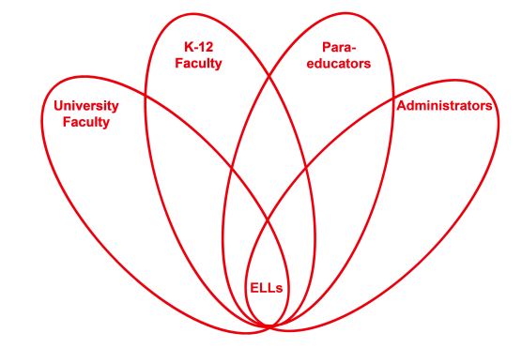

RETELL Strategy Implementation in the Classroom

Teacher | Melissa Carter
Content Area /  Grade Level | Health/ Gr. 3
Unit | Strategies for Victims of Bullying
Content Objectives | Students will be able to identify different ways a victim can stop a bully.
Language Objectives | CCSS.ELA-Literacy.W.3.1 Write opinion pieces on topics or texts, supporting a point of view with reasons.  CCSS.ELA-Literacy.W.3.1a Introduce the topic or text they are writing about, state an opinion, and create an organizational structure that lists reasons.  CCSS.ELA-Literacy.W.3.1b Provide reasons that support the opinion.  CCSS.ELA-Literacy.W.3.1c Use linking words and phrases (e.g., because, therefore, since, for example) to connect opinion and reasons.  CCSS.ELA-Literacy.W.3.1d Provide a concluding statement or section  Using a graphic organizer, students will be able to write a paragraph describing 3 ways they would try to stop a bully.  Language Objective Differentiation for Proficiency Levels:  Level 1 & 2  Students will be able to write simple sentences or list 3 ways they would try to stop a bully and draw a picture of each.
Strategy | Think Aloud
Brief explanation of how the strategy was used | -Review the differences between bullying and normal conflict using think, pair, and share.  -7 step process for new vocabulary  -Read “Arthur’s April Fool” by Marc Brown and model making connections through the think aloud strategy and have students give a thumb up when they have a connection to share.  -Front Cover Think Aloud: The title “Arthur’s April Fool” reminds me of April Fool’s Day when people play tricks on each other and in looking at the picture he looks like a magician about to pull a rabbit out of a hat. I wonder what kind of trick he might play.  -p. 3 I can tell Binky Barnes is a bully because Arthur says “he keeps threatening me” and then he stole his pen. I remember from our definition of a bully that it is someone who repeatedly picks on someone else.  -p. 9 The pictures on this page remind me of the story “Bullies Never Win” because Jessica had a bad dream just like Arthur in this story. She was afraid to go to school because of a girl picking on her too.  -p.14 I also noticed the word “worried” is repeated on this page 3 times. I heard this word on the other pages as well. This word was one of our vocab words from “Bullies Never Win”. I remember it meaning anxious, nervous or scared. I think Arthur feels nervous or worried because he thinks he is going to get beat up by the bully.  -p. 15 When Binky calls Arthur a “pipsqueak” and a “shrimp” it reminds me when I was in school and I would get teased. They would call me turkey legs or butterball turkey. It would hurt my feelings. It also reminds me of when Jessica was called “toothpick” in “Bullies Never Win”.  -p. 19 Binky looks worried on this page. I can tell because it says his face turns pale and he steps back. When I get scared or feel sick sometimes my face turns white. Now Binky feels the same way that he made Arthur feel.  -p.27 I like how Arthur’s friends said that he did his best trick yet because he made Binky Barnes disappear. In the story, Arthur tried and failed to do magic tricks for the school show. I think it is interesting the only trick that truly worked was when he stood up for himself.  -Discuss through turn and talk about how Arthur was able to stop the bully. Have students discuss what they would have done if they were Arthur? Would they have played a trick on the bully like Arthur did? Why or why not?  -Brainstorm other ways to stop a bully through think, pair, and share.  -Model using a graphic organizer using transition words to write a paragraph or to create a list\sentences of three ways they would try to stop a bully.
Reflection: How and why was the strategy effective? What might you change for next time? | The think aloud strategy used in reading the story helped my ELLs by modeling how to make connections. My ELLs were able to share their connections to the story and therefore were able to relate to how Arthur was bullied in the story. It also helped to build upon what they already knew about bullying from previous lessons and stories already read. It was easier for them to then discuss ways to stop a bully. My ELLs felt more comfortable discussing how to stop a bully because they were engaged in thinking about what was being read to them and how they could relate. They also built off of one another’s connections in the class too. In addition, they were able to show more clearly through their writing and drawings how to stop a bully.  The next time I try this strategy, I would try to make sure to not overdo the think aloud strategy so that the flow of the story is smooth. It would allow for the connections to be more meaningful and to be more focused. I also think it is important to make sure the students stay on topic as well.

