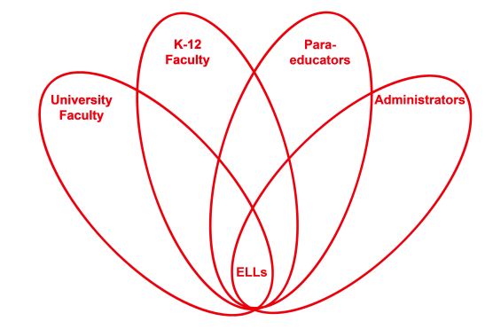

RETELL Strategy Implementation in the Classroom

Teacher | Diane Fortier
Content Area /  Grade Level | Kindergarten
Unit  (Topic or Skill) | Using text features to better understand a story
Content Objectives | Student will understand that the book jacket and text features may give additional clues for the reader to understand the story better.
Language Objectives | Student will be able identify what features are present in the text or on the jacket saying what they think the features tell the reader.  Language Objective Differentiation for Proficiency Levels:  WIDA level 1 will be able to point to text feature and describe with a single word or gesture.  WIDA level 2/3 will be able to point to text feature and describe with short phrases.  WIDA level 4/5 will be able to describe the text feature using phrases or sentences and describe with phrases or sentences.
Strategy | Analyzing Text Features
Brief explanation of how the strategy was used | Begin the reading focus lesson by saying that good readers look for clues the author and illustrator leave by the ‘text features’ on the cover and in the print of the book. These clues can often help the reader understand the story better. Introduce the book Bunny Cakes: by Rosemarie Wells, read title, and ask the students to look closely at the cover and text. Make predictions about what the story might be about. Did the author/illustrator use text features as clues to understand the story better? By looking at these text features does the reader have any questions? Chart the responses on chart paper to be reviewed after reading the story.  Look at the cover, the back cover and the title page closely, discuss size, position, color and picture. Note text features and predictions on chart paper.  Read book. Refer to the chart to see if the text features helped to understand the story and if the predictions made were correct.  Send student off to ‘Independent Reading’ time with their own book bags to investigate the text features and the clues in their books. Teacher and paraprofessional circulate among tables observing, questioning and commenting on students’ findings. Students’ book bags are leveled for each student.  Two students share what they have discovered with their books after 10 minutes of independent time.
Reflection: How and why was the strategy effective? What might you change for next time? | This strategy showed the ELLs how important these little features are and that they have a huge impact on the story. They were able to show that they understood the lesson by pointing things out, speaking, or responding to others’ comments. Typically, these students need to be refocused often when stories are being read. They are quiet when questions are asked during or after the story. This lesson gave them a visual that they were thinking about and were able to refer back to it. It kept their attention and gave them confidence. This was the first time an ELL girl volunteered an answer when we were reviewing if the text feature helped readers understand the story better. She was able to articulate that she understood now what we were talking about. Since I have taught text features before it was interesting that these students are now showing comprehension of this. It is true that those introductory lessons were when most of these students had come to school for the first time. Some were hearing English only for the first time. The affective factor plays in with the retention of the lessons. It was good for me to see that and reflect on other lessons that may need to be reviewed for this reason.  As we reviewed the hypothesis and predictions that were made, we asked whether or not the text features helped them understand the story. The students voted using words or thumbs up or down. At one point one of the students took the book from my hand and found the page that answered the question. The Level 2 students are the ones that really jumped in to indicate they were helped by this lesson. The most interesting time for this lesson was after they went to their own books and eagerly began looking for clues. They have had these books in their bags for over a week and yet still were excited about going and relooking at the books to see what text features they could find. They talked with each other about what their book had and compared. They all wanted to share at the end. One of the students I chose to share was a girl who needs to be encouraged to join in. This lesson gave her the confidence to speak up and want to share. Analyzing text features in her book gave her the opportunity to do so successfully.  To increase my ELLs’ engagement and interaction, the next time I try this strategy, I would try taking the ELLs aside before I begin the daily read aloud and review the text features with them. This will give them the time to assimilate what they see before adding all the extra language from the story and the other students. When I began this lesson, I saw when the ELLs started to disengage or perhaps ‘settle in’ to be in the group perhaps not really listening. The minute they comprehended a text feature or had a question to focus on, they tuned in completely to the story. There was a point in the story where one of the students was trying to indicate what would happen in the future by gesturing to the illustration and using words. This engagement of the ELL students was much better than a typical read aloud story time. By previewing the text with these students it might spark their attention.  In addition, this strategy can help students on a daily basis as they pick up an independent reading book or go to the class library (or perhaps pick up a book at home). For the next few days I will choose storybooks that have engaging or different types of text features to continue this theme and see how the students respond.

