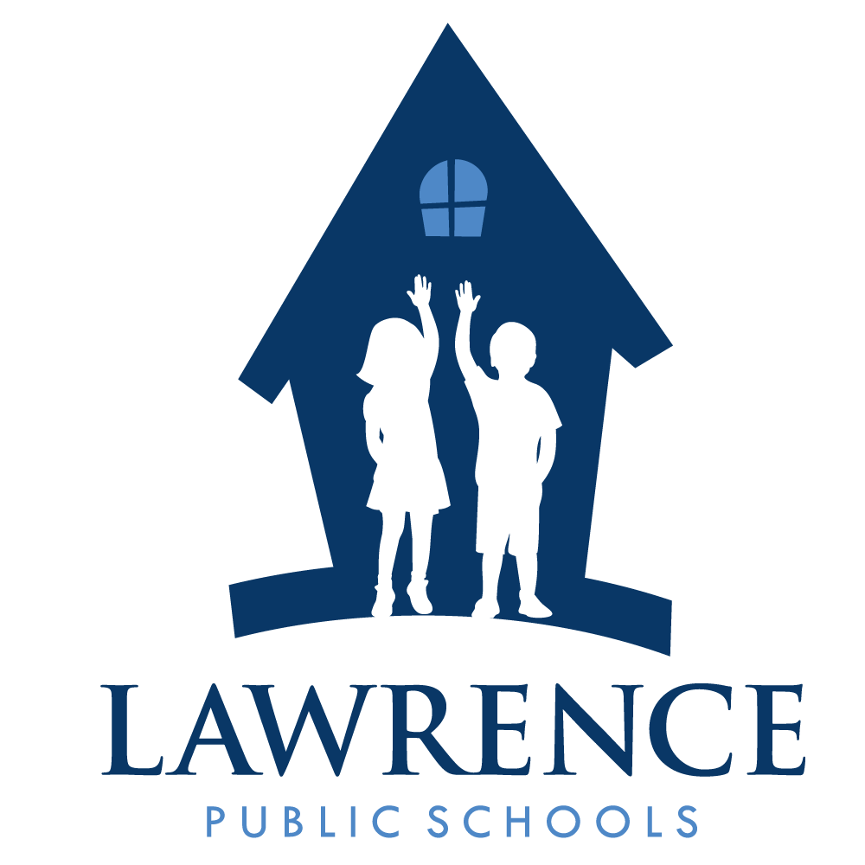
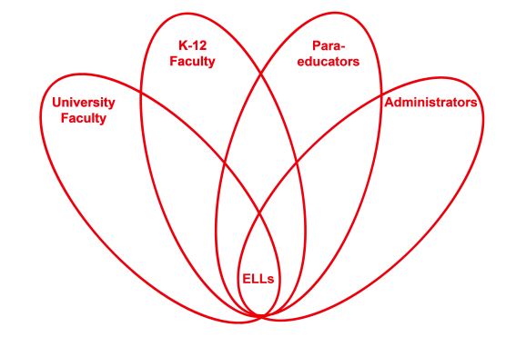

RETELL Strategy Implementation in the Classroom

Teacher | Joshua Segaloff
Content Area /  Grade Level | Science Middle School Grade 7
Unit  (Topic or Skill) | Nonfiction text features reading comprehension
Content Objectives | Students will be able to recognize author, illustrator, title page, table of contents, and other particular elements as identifying items of information about a non-fiction book.
Language Objectives | Students will be able to identify, write, and speak different elements of non- fiction text.  WIDA levels 1-3 Students will be able to identify particular elements of non-fiction  WIDA levels 4-5 Students will be able to identify specific informational texts
Strategy | Text Features
Brief explanation of how the strategy was used | An anchor chart displaying elements of Non-Fiction Texts  Connection: Yesterday we learned what non-fiction was, how it’s different from fiction, and how to identify non-fiction books based on particular elements.  Explicit Instruction (Show them exactly how to do it): Today we are going to continue practicing identifying non- fiction books as well as using their elements to help us learn more about a certain topic. Today, each of you is going to get this Non-Fiction Book Report Flip Book where each page requires you to utilize a different element of non-fiction text. Watch me as I read my non-fiction book and fill out the first three pages of the flip book....  Guided Practice (Ask them to try it with you or with a partner.) Now it’s your turn... How would I complete the next page in my flip book? Turn and talk with your partner on what I should write.  Send Off for Independent Practice: Today as you read your non- fiction text, I would like you to complete the first three pages of your non-fiction flip book.  Group Share: Who did some great work today? Who would like to share their flip book?
Reflection: How and why was the strategy effective? What might you change for next time? | In terms of productive text features, perhaps none is more important than the use of pictures. As language is developed it’s vital to link words to something tangible. Content can only become comprehensible when the given vocabulary is understood. This is a major dilemma for teachers of ELLs. Pictures in various forms—posters, newspapers, magazines and especially student produced art work in the form of paintings or pencil illustrations—give the students ownership and a connection to the vocabulary word.  This strategy greatly helped to produce both academic language and productive discourse. Academic language was produced when students were using selected words and matching them to the drawings. By capitalizing on a strength that the majority of my students have, I was able to promote this technique and simply float from group to group to listen to productive discourse as each student conversation included vocabulary from our word bank. Pictures are a great way for students to illustrate meanings and to showcase their understanding of topics which leads to meaningful productive discourse.  The picture/drawing activity went well. In the future, I would provide pictures, posters, and paintings for students to choose from as an option. I noticed that I had two frustrated students who were not proficient artists and one group spent too much time drawing and not enough time on labeling and discussing. By providing pictures to those groups, discussion will get underway and more positive discourse will happen.

