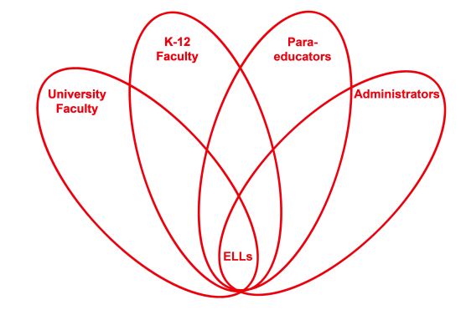

RETELL Strategy Implementation in the Classroom

Teacher | Elisha Ayala
Content Area /  Grade Level | 5th Grade Math
Unit  (Topic or Skill) | Decimals
Content Objectives | We will solve real-world problems by computing decimals.
Language Objectives | Students will use text features to engage in problem-solving.  Language Objective Differentiation for Proficiency Levels:  Level 1: Students will recite key words or phrases from the article.  Level 2: Students will describe pictures, events, or objects from the article using phrases or short sentences.  Level 3: Students will present content-based information that will help them solve the problem.  Level 4: Students will offer solutions to real-world problems.  Level 5: Students will explain in detail how they solved the real-world problem.
Strategy | Identifying Text Features
Brief explanation of how the strategy was used | This strategy was used during my Math Intervention class. We have been reviewing Common Core standard 5.NBT.7, which is computing decimals, and I thought using a current article from Scholastic Math would give students an opportunity to apply what they’ve learned to the real-world. Students were given a chart on informational text features. Before reading the article, “Gadgets Get You Moving”, students used their chart on informational text features in a small group to identify all the text features they saw in the article. Then as a whole group, the reporter from each small group shared one text feature their group identified (title, bold print, photos, labels, italics, captions).
Reflection: How and why was the strategy effective? What might you change for next time? | This strategy helped my students easily navigate the article they read. Using the informational text features chart also provided additional information to help the ELL students comprehend the text. This strategy allows ELL students to look at how the text is structured, even when solving math problems. ELL students were able to go back and look at pictures or read captions if they didn’t fully understand what a gadget was.  This strategy helped my ELL students produce academic language and discourse by allowing students to give examples and non-examples of vocabulary words using pictures from the text. For example, students were able to identify a picture of a watch from the text as an example of a gadget. They were also able to identify that a picture of a person from the text was a non-example of a gadget. Using text features helped my ELL students identify important parts of the text (bold words) and rely on text features to help them comprehend the text.  Next time I try this strategy, I would probably incorporate physical activity. The article talks about different gadgets that promote physical activity so I would have students perform the physical activity in the real-world problem to help them calculate the answer.

