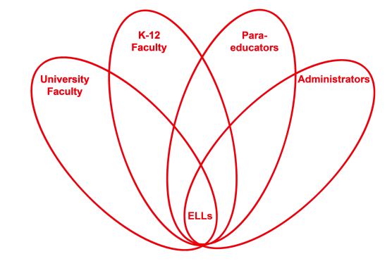

RETELL Strategy Implementation in the Classroom

Teacher | Melissa Carter
Content Area /  Grade Level | Health/ Gr. 3
Unit | Comparing Conflict and Bullying
Content Objectives | Students will be able to identify the differences and similarities between conflict and bullying.
Language Objectives | CCSS.ELA-Literacy.RL.3.7 Explain how specific aspects of a text’s illustrations contribute to what is conveyed by the words in a story (e.g., create mood, emphasize aspects of a character or setting)  (RL.3.8 not applicable to literature)  CCSS.ELA-Literacy.RL.3.9 Compare and contrast the themes, settings, and plots of stories written by the same author about the same or similar characters (e.g., in books from a series)  Students will be able to graph the similarities and differences between conflict and bullying using a Venn diagram.  Language Objective Differentiation for Proficiency Levels:  Level 1 & 2  Students will be able to graph the similarities and differences between conflict and bullying with a partner using a Venn Diagram using a word bank.
Strategy | Text Features
Brief explanation of how the strategy was used | -Review what bullying and the effects of it looks like through think, pair, share.  -Introduce new vocabulary through 7 step process  -Brainstorm examples of one of the new vocabulary terms “conflict” and discuss whether they have ever been in an argument or conflict with someone else.  -Preview the story “My Rotten Redheaded Older Brother” by Patricia Polacco. Identify text features using sticky notes and model for title, author, dedication page, quotations, capitalizations, illustrations, and color.  -Discuss how these features show that there is a conflict or an argument in the story. Think, Pair, and Share the following questions: What does the title tell you about who may be in a conflict? How do you think the girl feels about her brother? Have you ever been annoyed with your brother or sister? Why is the book dedicated to her brother? How do the brother and sister look in the illustrations? What colors do you notice the most? What feeling do you think of with the color red? Why are certain words all capitalized? What might be happening in the story? Since there are so many quotations in the story which characters do you think are speaking and what makes you think that.  - Have students act as detectives by playing “I spy” for different features on each page as you picture walk the story on the mimio. For example, teacher would say I spy a word in all capital letters and have students point out the word “SOMETHING” on the page. Have students share other features they spy on the following pages for the rest of the class to find. Discuss the purpose of each.
Reflection: How and why was the strategy effective? What might you change for next time? | The text feature strategy helped make the content more comprehensible because in the preview it set up the background of the conflict that was going to be read about in the story. By identifying and analyzing the purpose of the title, the dedication page to her own brother, the illustrations, the quotations, the all capitalized words, and noticing the colors used within the story my ELLs and the rest of the class were able to recognize that there was going to be a conflict or an argument between a brother and a sister. They were able to see and discuss how a conflict among siblings looks and how it is different from bullying after the story was read.  The text features allowed my ELLs to produce academic language because they were visually able to recognize the features and were able to discuss the meaning of it with a partner. They also were able to participate in pointing out the features in the story. More importantly, the text features were a catalyst for discussion and enabled my ELLs to make connections to their own lives on what it is like to be in an argument with a brother or a sister. It made the concept of a conflict more real to them.  The next time I try this strategy, I would want to try and use a nonfiction book because I feel it has more text features to discuss. I also feel it would help my ELLs engage in more academic language and expose them to more factual information that are within expository texts.

