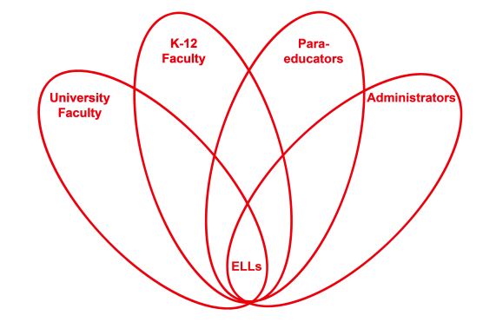

RETELL Strategy Implementation in the Classroom

Teacher | Sonya Dugan
Content Area /  Grade Level | Grade 2 ELA
Unit  (Topic or Skill) | Identifying Text Features
Content Objectives | Students will be able to identify specific text features (author, illustrator, title page, chapters, heading, bold print)
Language Objectives | Student will be able to identify and share 2 text features from a selected text  Language Objective Differentiation for Proficiency Levels:  Students at WIDA level 2:  - students will be able to identify (pointing) and/or orally state text feature in selected text  - students will be able to have conversation using vocabulary word(s) in context (author, illustrator...)  - students will be able to provide information using a graphic organizer (adding to chart paper)  Students at WIDA level 3:  - students will be able to orally state and/or write at least 2 text features found in selected text  - students will form simple sentences using vocabulary word(s) in context (author, illustrator...)  - students will be able to provide information using an indivdual graphic organizer
Strategy | Identifying Text Features
Brief explanation of how the strategy was used | Sequence:  - Text: Frank the Fish Gets His Wish by Laura Appleton-Smith  - Explain that we are learning about "text features". Explain what those 2 words mean in student-friendly terms.  - Comments/answers are shared orally and recorded on chart paper for reference  - Wrap up: students will pick a different book and share 2 text features from that book
Reflection: How and why was the strategy effective? What might you change for next time? | This strategy allowed my students to feel successful right from the start of the lesson. They were able to easily identify some of the features we talked about (author, illustrator, title page, chapters...) and even though they may not have been able to read what it said (in some cases), they were able to identify it quickly throughout the text (visually) and they were able to feel good about this. It's always exciting to see them feel proud and successful - that develops into wanting to do more. Being able to identify these text features required the students to be more focused on all the print in the book. I think this will be even more important as they move into higher levels of texts and grades - particularly when they use non-fiction texts.  When we went through our book together, I stopped at each identifiable feature and we discussed it. (Why was it there? Why like that? What did the author want us to do? Why?) I noticed that when the students were examining their own books, that they would stop and point out a feature and discuss it with me and/or peers as we did in our shared time. This allowed for academic as well as social language practice.  The next time I try this, I will not give them as many choices to pick from during the "practice" work. It was not necessarily a negative thing - but they were so excited that they could identify features in many of the books that were available, that they seemed to skim the book as opposed to getting "into" it. I think for the practicing, I would limit their choices next time, but their classroom independent reading time, it would be a more appropriate time to offer several choices for them to use.

