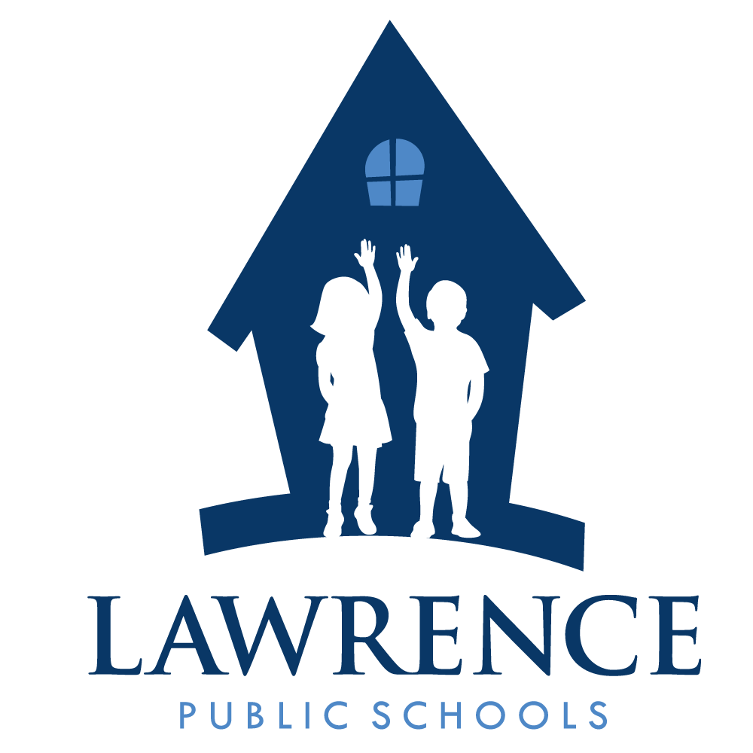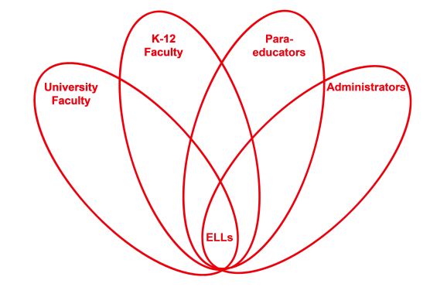

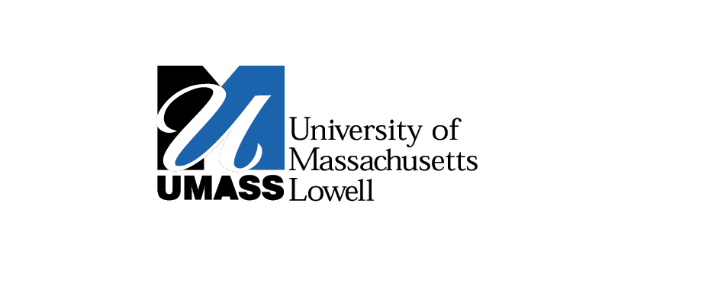

**RETELL Strategy Implementation in the Classroom**

|  |  |
| --- | --- |
| **Teacher** | Eileen Lannan |
| **Content Area /**  **Grade Level** | Reading - 8th grade |
| **Unit**  **(Topic or Skill)** | Civil Rights – Montgomery Bus Boycott |
| **Content Objectives** | Students will understand how the philosophy of non-violence shaped the civil rights movement. |
| **Language Objectives** | Student will improve reading comprehension by analyzing text features in the book, Freedom Walkers.  Level3 - The students will discuss the illustrations and then orally pose questions regarding what they understood and what they did not understand.  Level 4 – The students will discuss the text features and then write questions on sticky notes, regarding what they understood and what they did not understand. |
| **Strategy**  **(Name or Type)** | Text features |
| **Brief explanation of how the strategy was used** | |  | | --- | | **Text Features:** Book Cover, Table of Contents and Pictures.  http://3.bp.blogspot.com/-d309kmAkLnc/UmCwC6ZemvI/AAAAAAAAACY/3eUm_pmHHTg/s1600/freedom-walkers.jpgThe students analyzed the book cover. They looked at the table of contents describing the chapters in the book. Most of the chapters focus on famous African-Americans during the civil rights movement who were involved in the Bus Boycott and those who fought for equal rights. We looked at the author’s use of numerous and impressive black-and-white photographs that show the segregation of that time period. There are also photos of those involved in the Boycott as well. | |
| **Reflection: How and why was the strategy effective? What might you change for next time?** | **How did this strategy help to make the content comprehensible to ELLs in my classroom?**  This was an excellent strategy to implement with the students for a number of reasons. First, it takes the stress out of the ‘unknown’. We just completed the word wheel as a strategy for vocabulary. Now, we take our time and look at the book cover and try to extract information from the picture. This creates an atmosphere of ongoing discussion and critical analysis. Students always have some anxiety about starting a new book and this strategy works well to reduce that anxiety and give the student a chance to absorb the information and think about the kind of story they are about to read. The students can then talk about key points in the photo they believe relate to the story. Students are very good at picking out details in photos, so the teacher better have looked them over well herself!  Next, we opened the book and read the table of contents. This was a good opportunity to get a sneak peek at what we would be reading and see who the key players of the civil rights movement were. The table of contents described the introduction and eight chapters in the book. Some chapters focused on people, whose names were unfamiliar to us, and other chapters focused on famous African Americans whose names were already familiar to the students. This gave us a chance to tap into some prior knowledge as well. The table of contents also hinted to key events during the times of segregation. Students were very anxious to tell me what they knew about the famous people and events mentioned in the table of contents (Dr. King, Rosa Parks) and made predictions the other unknown people mentioned, were heroes of some kind.  Then we took some time to view the carefully selected, spectacular, black and white photographs throughout the book (numerous photos). The pictures are very telling of the times and tell a story all on their own. You get a clear sense of the injustices looking at these photos and we see the everyday people who dared to challenge those injustices. The students are really involved and very inquisitive about the pictures. Of course, there are captions under the pictures which some are reading out-loud. They are beginning to hammer away with questions and predictions. One photo shows members of the KKK driving around, dangling a rope in the shape of a noose out an open window of a car. Someone guessed it was probably to scare the black people. Photos like this can be very disturbing at first glance and often spark a lot of discussions. The students want to talk about these photos and they want answers, mostly as to why someone would act this way or treat others this way. I don’t like to say too much and give away the reading. It is clear that they are almost ready to begin. We end class and I tell them we will begin to read soon enough. I hear the heavy sighs.  This strategy helped the ELLs produce academic language and discourse, because in reviewing the contents and the photographs, we talked and talked and talked. While we talked I took every opportunity to use academic language and develop the vocabulary associated with this book. The more I used it, the more they used it. Discourse IS language use; it promotes vocabulary development and comprehension. It is a win, win. Before we even start reading, the vocabulary words are used multiple times, each. Civil rights and the whole concept of injustice is so rich in opportunity for discussion and the more we partake in discussion the greater the opportunity we have to use the language. One just naturally evolves into the other. I love teaching this unit and I am very enthusiastic. My principal, who had observed my class this day was very impressed by the students’ level of discussion and use of content vocabulary, given the reluctant, low level learners I teach. I strongly believe that what a child lacks in one area, they make up for in another area. I prefer to have intelligent conversations anyways. And, for the record, most students I teach are not reluctant learners, they are reluctant writers, and when given the opportunity to learn in an atmosphere where discussion is ongoing and a priority, they love it.  Next time, I would definitely bring in more props etc. I need some posters, and more visual materials. I really need to invest some money towards supporting my reading materials. I like to be totally engrossed in the content I am teaching. Photos and posters are a good way to do this. I often like to set up photo galleries for the students. This gives them a chance to look at and analyze photos as they relate to our unit of study (ie, holocaust). A great deal of understanding can be had through photographs. It just so happens, I don’t have posters or photos for the civil rights unit. Maybe this will inspire me to change that. **The Help,abilinequote**As a Special education teacher, I do love to surround my students with materials that engage and excite them. I also like for them to take away something tangible to remember the unit of study or just a good book we read. To set the stage for this unit, and just prior to reading this book, I showed the movie “The Help”. The movie takes place in Jackson, Mississippi and details the lives of African American maids and the hardships they faced, daily. The movie really portrays the south as it was during segregation and under Jim Crow laws. The photo to the right is from the movie and so, I had postcards made of this picture for every student in my reading group. They love this postcard. For snack this day and to hook them in, I served chocolate cream pie that I made special for them! |