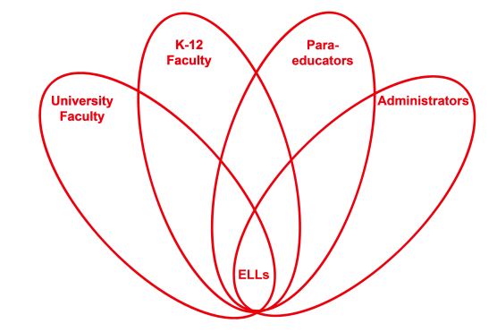

RETELL Strategy Implementation in the Classroom

Teacher | Stacy Sirmaian
Content Area /  Grade Level | Kindergarten
Unit  (Topic or Skill) | Family
Content Objectives | ELA-Literacy SL.K1 Participates in collaborative conversation with diverse partner about kindergarten topics and texts with peers in small groups and larger group.  ELA- Literacy SL.K1.B continues a conversation through multiple of exchanges.  SWBAT to demonstrate and understand who a relative is and name them.
Language Objectives | SWBAT to orally discuss the relatives in their family; they will be able to understand what a relative means in writing and drawing.  Language Objective Differentiation for Proficiency Levels  L1 Point to picture, use gestures  L1 Draw a simple picture  L2 Speak in a simple phrase  L2 Draw a relative and label it using letters
Strategy  (Name or Type) | Seven Step Vocabulary
Brief explanation of how the strategy was used | 1. I pre-taught the vocabulary “relative”, “disappear” and “strange”.  2. I said the word, then students repeated it 3x (whisper it, clap it, shout it).  3. I read the vocabulary in the context.  4. I explained the vocabulary in kid friendly terms.  5. I highlighted the word by looking at the beginning letters in the words and broke the words down into syllables.  6. I provided examples of relatives by showing a picture of my family (relatives) and stated, “A relative of mine is my_____”.  7. Students were then provided with sentence frames to guide their oral discussion of their relatives, “A relative is___________.”  8. While I read the story, each time they heard the word in the story they put their finger on their nose, so they could recognize the word in context.  8A. I also provided a quick example of the vocabulary “disappear” and “strange” by having the students dramatize the meaning.  9. After the story, we sorted pictures by relatives/ not relatives onto a T chart.  10. I then tied the word “relative” into their writing . The students created a Relatives Book. They were provided a sentence starter “I love my _____’’as a resource.
Reflection: How and why was the strategy effective? What might you change for next time? | I chose the vocabulary to fit he content and the supplementary material so the lesson would be more clear and meaningful. I provided my ELLs with repetition of vocabulary through a variety of techniques such as modeling, visuals (pictures), dramatization, and gestures to help be more comprehensible. I also felt by providing the ELLs the opportunity to turn and talk with sentence starters and paraphrasing they could process and produce the language they needed.  The next time I use this strategy, I would like to implement asking questions and using the thumbs up/ thumbs down for on the spot assessment to monitor for understanding. I would also like to implement the Social Studies content vocabulary across the curriculum. For example, using relatives to tell additional stories in their math lessons.

