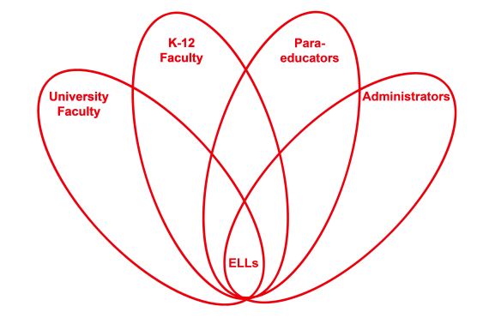

RETELL Strategy Implementation in the Classroom

Teacher | Kate Vachon
Content Area /  Grade Level | Kindergarten
Unit  (Topic or Skill) | Understand the Common Core critical vocabulary word compare
Content Objectives | Students will understand and use the Common Core critical vocabulary word compare.
Language Objectives | Students will use the Common Core critical vocabulary word compare when comparing two objects.
Strategy  (Name or Type) | Seven-Step Vocabulary Process
Brief explanation of how the strategy was used | 1. teacher says “compare” and the students repeat  2. teacher says, “We are going to compare a pumpkin and an orange.” realia: hold up an orange and a pumpkin  3. teacher says, “Compare means to find what is the same.” Students repeat  4. teacher says, “Compare begins with the /k/sound. What letter makes the /k/ sound?” students respond  5. teacher says, “Let’s compare the pumpkin and the orange.” Discussion of attributes takes place  6. teacher makes a Venn diagram on chart paper and records the student’s answers on the diagram in the appropriate spots  7. students then choose two objects from the provided sets of realia then go to their seats and draw a picture and write words comparing two objects
Reflection: How and why was the strategy effective? What might you change for next time? | Using the realia was essential. Students had fun choosing the two objects they compared independently. The students were observed to use the word compare during other times during the day.

If you created any handouts, presentations, or other materials to implement the strategy in the classroom and to support English language learners, please include those as well so we can share them with other teachers.

Please send this form and any additional materials as attachments to emilymrobichaud@gmail.com

