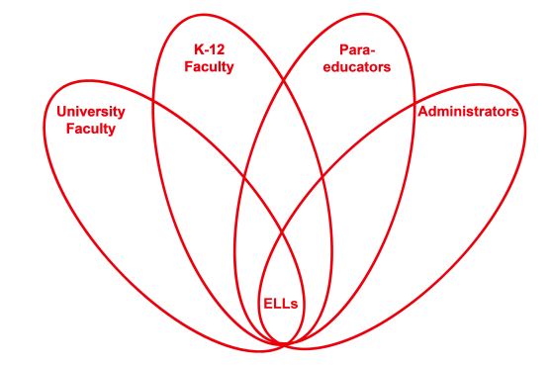

RETELL Strategy Implementation in the Classroom

Teacher | Stacy Sirmaian
Content Area /  Grade Level | Kindergarten
Unit  (Topic or Skill) | Fall
Content Objectives | ELA-Literacy- RL.K.10 Actively engages in group reading activities with purpose and understanding.  Content Objective:  SWBAT define the word “harvest” using a sentence frame.
Language Objectives | Language Objective:  SWBAT create a complete sentence orally and written on their own, using the word “harvest” and what it means, in a sentence frame.  Language Objective Differentiation for Proficiency Levels:  L1: I can repeat a simple phrase using a sentence.  L1: I can draw a picture  L2: I can answer with one or two words.  L2: I can complete phrases in the poem  L2: I can copy a familiar phrase using a sentence frame.
Strategy | Sentence Frame Strategy
Brief explanation of how the strategy was used | In a small group, I reviewed the word wheel we created the day before. In order to help the students recall the words, I helped to prompt them by demonstrating the act of picking vegetables from a garden. We then recited the poem, “The Harvest” using the my turn /your turn approach incorporating plastic vegetables and gesturing throughout for better understanding. Students were given the sentence frame “Harvest is__________” to practice speaking in a complete sentence. I then wrote their responses on a large paper. The students were given a paper to have the opportunity to write down the sentence they practiced speaking and include an illustration to match their sentence. The students shared their responses by speaking in a complete sentence, “Harvest is picking.”
Reflection: How and why was the strategy effective? What might you change for next time? | This strategy enabled the students to respond in speaking and writing in a simple sentence structure. When the poem was recited through “my turn, your turn,” the students were engaged orally. After collaboration with my colleague, we felt the poem was too long for the ELL students, especially in the small group setting. We have come to realize the importance of choosing a poem that better supports the targeted word through context and frequency. Through this lesson, the word “vegetable” was an unknown word. The word vegetable will be worked into our lessons next week.  The environment was not conducive to the lesson due to the circumstances of not having a para that day and the time being so late in the day in which the students were instructed. This activity would be more beneficial if it was done in the morning.

