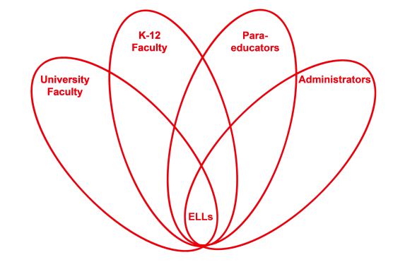

RETELL Strategy Implementation in the Classroom

Teacher | Joshua Segaloff
Content Area /  Grade Level | Science Middle School Grade 7
Unit | Nonfiction Science reading comprehension
Content Objectives | Students will be able to define vocabulary words for A Day in the Life of a Computer
Language Objectives | Students will be able to correctly use vocabulary words in sentence starters.  Language Objective Differentiation for Proficiency Levels:  Students will be able to match labeled pictures to those in illustrated scenes from the story: A Day in the Life of a Computer (WIDA level 2)  Students will be able to use pictures to identify vocabulary words from: A Day in the Life of a Computer (WIDA level 3)
Strategy | Sentence Starters
Brief explanation of how the strategy was used | Sentence starters were effective as a tool for teaching comprehension to my Second Language Learners. They fit into the chronological order of my instructional style. Beginning with the posting of the given word bank, featuring both key and multiple meaning words, we, as a class, are growing as readers and writers. The sentence starters are flexible as they can be altered to fit students with WIDA levels 1-5. By constantly developing academic vocabulary and ensuring that our ELLs are comfortable with the definitions and are able to complete sentences in both cloze and creative writing formats, we have found a sound strategy to make content comprehensible.
Reflection: How and why was the strategy effective? What might you change for next time? | After using sentence starters in partner groups to both create and produce student generated sentences, I saw an increased confidence level of my reading group. This was determined by their willingness to orally share their sentences during the “share out” portion of our formative assessment piece. Discourse is encouraged and applauded when academic vocabulary is used and topic-related discourse takes place. Sentence starters made the task less daunting and therefore serve as a catalyst to jump-start student participation in writing; perhaps the most difficult of the four domains of language to master. To increase engagement I would add an illustration component to the lesson. Capitalizing on my students’ creativity and the love of expression through drawing, this would be the perfect way to both begin a project and connect reading, writing, and art.

