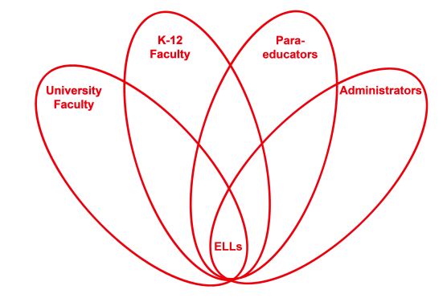

RETELL Strategy Implementation in the Classroom

Teacher | Diane Fortier
Content Area /  Grade Level | Kindergarten
Unit  (Topic or Skill) | Winter vocabulary
Content Objectives | Students list things they know about the topic of ‘winter’.
Language Objectives | Students named or identified things that relate to them about winter.  Language Objective Differentiation for Proficiency Levels:  L1 will answer yes or no questions to the question ‘Does this happen in winter, or do you need this in winter?’ when teacher named items or showed a picture.  L2/3 will choose pictures that are winter related out of a given group.
Strategy | Roundtable Learning
Brief explanation of how the strategy was used | Students took turns saying and writing something that reminded them of winter. Once they said and wrote something they passed the paper to next student.
Reflection: How and why was the strategy effective? What might you change for next time? | This was a background knowledge gathering activity for my students. I know some of the students have not seen snow or have not been in the cold climate for a winter yet so I wanted to find out what they knew about winter. They seemed to really enjoy the activity. The list they created grew longer as each of the students spoke. Each new word sparked a new thought from another student. Some students could not name the item but described it and the other students named it. I named one item for a description that a student gave but no one could name. I had pictures of winter items that I used only if students got stuck and could not come up with any word. I used translation for my lower L1 student. I also noticed that some students used words from our current unit which was appropriate. This list of words now will be used for the word wall with pictures to match and the students can refer to them at writing. So this strategy reviewed some of the content from the last unit as well as prepared the students for the unit content to come. It also gave me an idea how much realia I will need to bring in for these next vocabulary words for the students have not seen or experienced snow or icicles.  This was mostly an oral activity for all the students. They were very invested in thinking about and responding to the topic. Some students were frustrated when they could not draw or write the word they were thinking of. I needed to encourage any type of drawing or writing but mostly focus on the spoken language. I walked around the circle with the paper helping to write the word they were trying to draw if they were frustrated. This moved the lesson at an appropriate pace. As students got the idea of the lesson they were trying to draw things for each other and were shouting out what letters to write down. I allowed students to skip a turn once if they did not have a word, giving them the wait or thinking time. However, the third time the paper went around, I showed pictures or gave clues to help those students speak. I found that some students could come up with an idea after listening to others label an item. Students came up with simple words first and as the roundtable continued more complex words were spoken. They started with ‘ice’ and later came up with ‘icicle’. They started with ‘snow’ but came up with several words with snow in it such as ‘snowball’ and ‘snow mountain’. One of the students said ‘fight’ while demonstrating gathering snow, balling it up, and throwing it. This strategy allowed all students to produce academic language that was related to the topic as well as prompting discussion among students. It was also interesting to see some students’ curiosity grow as one of the students mentioned something. Students questioned each other.  As a writing activity this was a bit frustrating for these students at this time of the year or for the first time this technique was used. I modified the activity as soon as I saw they had many more ideas than they could write and the writing was dragging the lesson down. The goal of the lesson was to get their thoughts on the topic quickly and gather information from each other, expanding the list. I did not want them getting frustrated or tied down by trying to sound out a word or draw something. I also wanted everyone to be involved. The results of the lesson were positive: all students participated using various methods. As a result of using this technique I will modify the strategy and use it more often. I may use it in a smaller group and then guide them through drawing pictures or spelling the word. I also think that I could use this for each letter of the alphabet.  As an extension of this lesson I would like to do this again at the end of the next unit and see if they would be able to spell or draw pictures after working for some time with the topic and word wall words. It would be interesting to see if they could then make the list longer or more creative.

