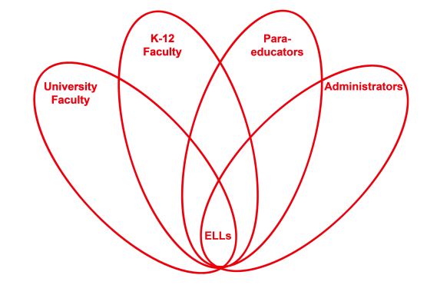

RETELL Strategy Implementation in the Classroom

Teacher | Heidi DeLucia
Content Area /  Grade Level | Kindergarten
Unit  (Topic or Skill) | Phonemic Awareness
Content Objectives | SL.K.1a: SWBAT: Follow agreed upon rules for discussions  RF.K.2 SWBAT: demonstrate understanding of spoken words, syllables, and sounds (phonemes)
Language Objectives | Students will be able to orally state words created using given word families.
Strategy  (Name or Type) | Roundtable
Brief explanation of how the strategy was used | Students were given a specific letter sound (b) and asked to think of a word that began with that sound. They then wrote either the word or I finished writing it for them. They had to write the beginning letter. After completing the list we echo read it. We did this same lesson using 3 different letter sounds.
Reflection: How and why was the strategy effective? What might you change for next time? | This is a great small group strategy. The children all participated and were excited to share their word. In the future I can see myself using this strategy using word families and rhyming words.

