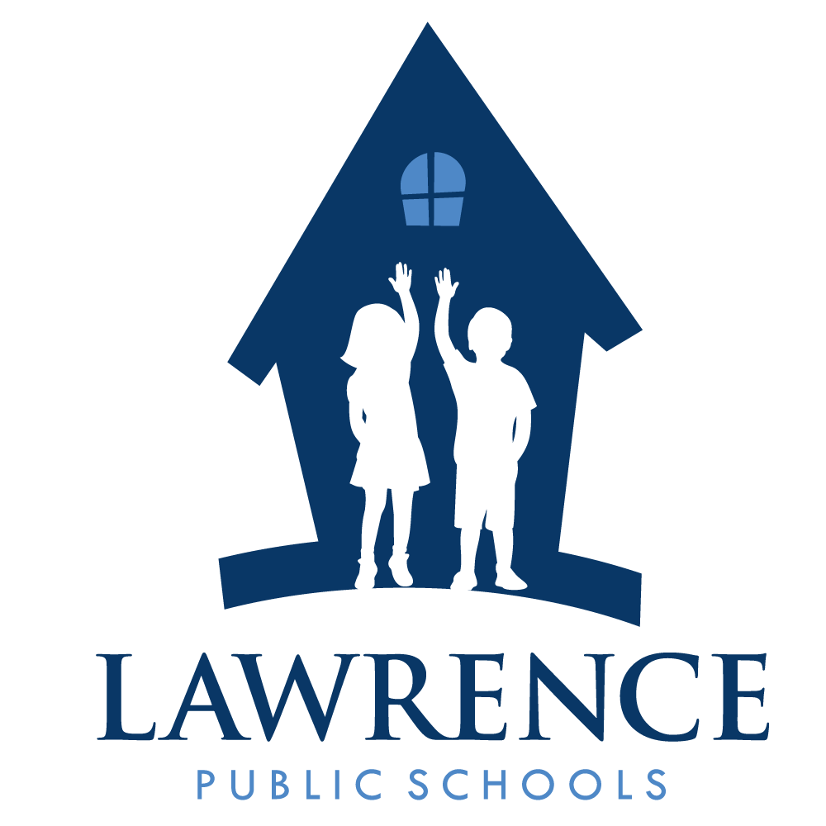
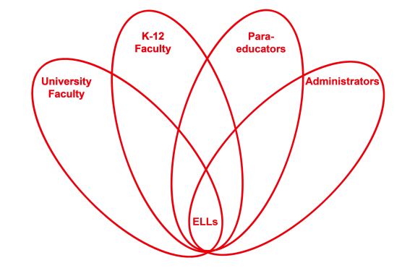

RETELL Strategy Implementation in the Classroom

Teacher | Linda Fiorillo
Content Area /  Grade Level | Literacy/Kindergarten
Unit  (Topic or Skill) | Christmas Traditions with emphasis on giving and receiving
Content Objectives | Students will use phonetic spelling to write a word that will be added to a group list.
Language Objectives | Students will describe an item they would like for Christmas and write it on a list.  Language Objective Differentiation for Proficiency Levels:  L1 Students will draw pictures and write at least the initial  letter of a word that describes what they would like for  Christmas and discuss it with their peers.  L2 Students will write a word that describes what they  would like for Christmas and discuss it with their peers.  L3 Students will write a word or phrase with details that  describes what they would like for Christmas and discuss  it with their peers.
Strategy | Round Table Learning Strategy
Brief explanation of how the strategy was used | Lesson Sequence  Vocabulary Focus: Generosity, Receive, Giving, list, favorite  Teacher discussed Christmas traditions and focused on Santa Claus and his generosity. Teacher read Santa and his Bag of Toys. After, teacher asked students what were ways to be generous and wrote a list so that children would get an idea of making a list so they would know what to do at the follow-up activity.  Partner Talk: Next, teacher asked students what they would like Santa to bring them for Christmas. (All students celebrate Christmas- I asked for a family holiday survey.) Students got in partners and shared their thoughts with each other.  Group Activity: Students were divided into 5 groups of 4. At each table was a large sheet of chart paper labeled:  “I would like Santa to bring me a_____________.” Students were encouraged to first talk about what they wanted. Next, they were to write their toy or item on the paper to form a list and draw a picture to represent their idea. Each writer needed to sit in the “writer’s chair” when it was his turn. Higher level children could write adjectives and details about their item and were encouraged to write sizes and color words to describe their items. Lower level children could draw a picture and attempt to write at least the initial sound of their item. All students at the table could help the writer if they asked for help.  Group Presentations: Each group stood before the class holding the chart and reading the word they wrote and describing the picture.  Conclusion: Writers’ can learn from each other as they brainstorm and write their ideas. Charts were posted in the hall.
Reflection: How and why was the strategy effective? What might you change for next time? | This strategy was very effective in helping students to write. First they had background knowledge which they received from the discussion and story so they knew and felt comfortable with the subject matter. Next, they were involved in an informal activity that demonstrated what was expected of them later at activity time and they were able to practice telling their idea as it was written down in a list form.  Partner talk allowed students to comfortably express their thoughts and organize their ideas about the subject matter. The cooperative discussion at the tables encouraged all children to do their best. The lower level children could see the process of how to write from more experienced children. They could see their printing and listen to their discussions about what they were writing. Middle and higher level students wanted to do well because they were excited and familiar with the subject matter and motivated by their friends’ ideas and discussions. Many children offered to help spell words which provided additional skill development to the lesson.  This was a great lesson. The students couldn’t wait to write their group lists. They liked sharing their ideas in partner talks. They wanted to keep talking but I had to limit their conversations due to the time. However, when they went to the tables, conversation continued and seemed to be focused on the subject matter which they loved talking about. Some students asked for help by saying how do you spell? or what letter comes next? Many volunteered help which boosted their skill level as well as the child receiving the help. The students were practicing the sounds of letters and combining the sounds to make words. They were talking and using descriptive words as they drew their pictures, which was a great and informal way to practice academic language.  I think the next time I do this lesson, I will expand upon it. The list will be used to further write a story about their toy. They could include descriptive words, reasons why they wanted the toy, who they would include to play with it etc. Another thing I think I could do is to make the lists in the form of a stocking to make it more interesting and fun. Each group could use craft materials to decorate their own stocking list and present to the group. This would make their list more meaningful because they would be proud of their list and want people to see it. It would attract them to want to visit it more and they might show their parents or friends the list thus exposing them more and more to the words and engaging in opportunities to practice the language

