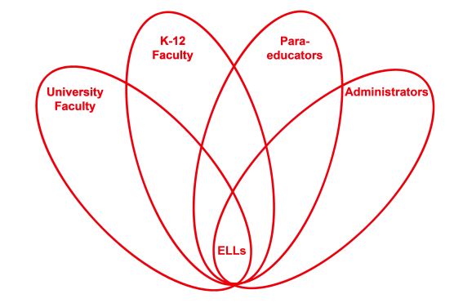

RETELL Strategy Implementation in the Classroom

Teacher | Kate Vachon
Content Area /  Grade Level | Kindergarten
Unit  (Topic or Skill) | The Gingerbread Baby by Jan Brett  Letter Writing
Content Objectives | Students will understand how to set up and write a simple letter.  L.MA.1a,f  L.MA.2a,b,c,d
Language Objectives | Students will use/offer known Tier One and Two vocabulary words when making suggestions about how to get the Gingerbread Baby to come to the _________ School.  Lower Level ELLs: Students will choose one of the choices offered by the teacher and repeat the choice. Ex. “Do you think we could tell the Gingerbread Baby we will make him a house or make lunch for him?”
Strategy  (Name or Type) | R.A.F.T. (Role-Audience-Format-Topic)  Role: Ms. ____’s Class  Audience: the Gingerbread Baby  Format: a letter  Topic: Getting the Gingerbread Baby to come to our school to stay safe.
Brief explanation of how the strategy was used | This is a drafting strategy that is directly related to a mentor text. It is meant to imitate a real-life situation (newspaper article, letter, advertisement, etc.). Can be used across all content areas.  Students/teachers choose what the R.A.F.T. will be. Teachers should do a mini-lesson on the format first.  Can be adapted for lower grades as a shared writing (as in this lesson plan).  This strategy allows for development of higher-level thinking skills (analyze, synthesize, generalize, etc.).  The teacher did a mini-lesson on basic letter writing by writing a letter to the class telling them what they were going to do. The teacher showed the students the R.A.F.T. anchor chart with the role, audience, format and topic written out.  The teacher then read the story, The Gingerbread Baby by Jan Brett to the class, stopping before the end. Vocabulary was also previewed.  The teacher and the class used shared writing to compose a letter to the Gingerbread Baby asking him to come to the _______ School so he would be safe and not get eaten (the class could decide another topic of the letter to the Gingerbread Baby). The teacher asks guiding/scaffolded questions as the letter is being written.  Once the letter is composed, the teacher and the class read it back together then read the end of the story to see what happened.
Reflection: How and why was the strategy effective? What might you change for next time? | This strategy was very effective and worked as a great lesson the day before Christmas vacation when the students were not really focused on learning. All students at various levels of language development were able to participate through the differentiation of questions, choices and tasks presented.  A follow-up activity such a writing a letter to a friend or family member would be a good idea. That could be differentiated by offering sentence starters to the lower level students and word banks for all students.

