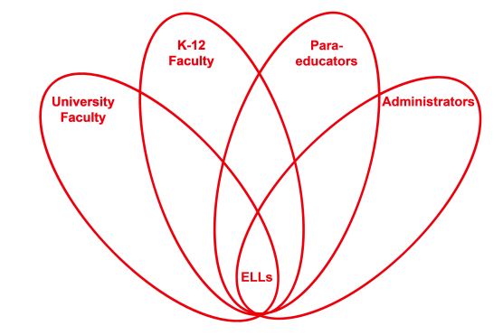

RETELL Strategy Implementation in the Classroom

Teacher | Andrew Larocque
Content Area /  Grade Level | Algebra 1/ Grade 9
Unit  (Topic or Skill) | CME: Algebra 1 Common Core  After lesson 4.04 on collinearity
Content Objectives | SWBAT:  - Create 3 points that are collinear and 1 that is not collinear  - Write an explanation for the reason 3 points are collinear and 1 point is not collinear
Language Objectives | - Students will write a letter as a non-collinear point to 3 collinear points using these vocabulary words: Collinear, slope, x-value, and y-value.
Strategy | R.A.F.T. (Role-Audience-Format-Topic)
Brief explanation of how the strategy was used | I used the RAFT as an assessment to show that the students can show three points are collinear and that one point is not collinear. They then explained how they knew that the points are collinear. The students did this in a letter as a non-collinear point to the three collinear points using specific vocabulary.
Reflection: How and why was the strategy effective? What might you change for next time? | This strategy allowed the student to show their different levels of understanding collinearity. The students could choose any three points to be collinear. Some students chose three points on a horizontal line having the same y-value. Other students chose a vertical line having the same x-value. A couple students picked a slope and found three points that gave them that slope meaning the points were collinear. A student who was visual graphed a line and then found three points on that line.  The letter made the students have to personalize their understanding of collinearity because they were writing as a non-collinear point to the three collinear points. The letter made the content relevant.  If I had lower level ELLs I would give them a paragraph frame and a letter template to help them formulate their thoughts and use the academic vocabulary.

Student Handout:

Name: _______________________________
Collinear Point Letter
There are four different points three of them are collinear. You need to make up the three points that are collinear and explain why they are collinear. You need to write a letter as the non-collinear point to the collinear points telling them how the non-collinear point feels. The letter can be as long as you want as long as it includes all the vocabulary words.
Vocabulary:
- Collinear
- Slope
- X-value
- Y-value

Grading Rubric
______ (50pts) Explain why the three points are collinear ______________
______(20pts) Letter Format ______________
______(20pts)Include all the vocabulary ______________
______(10pts)Creativity ______________

Grading Score: ________________

