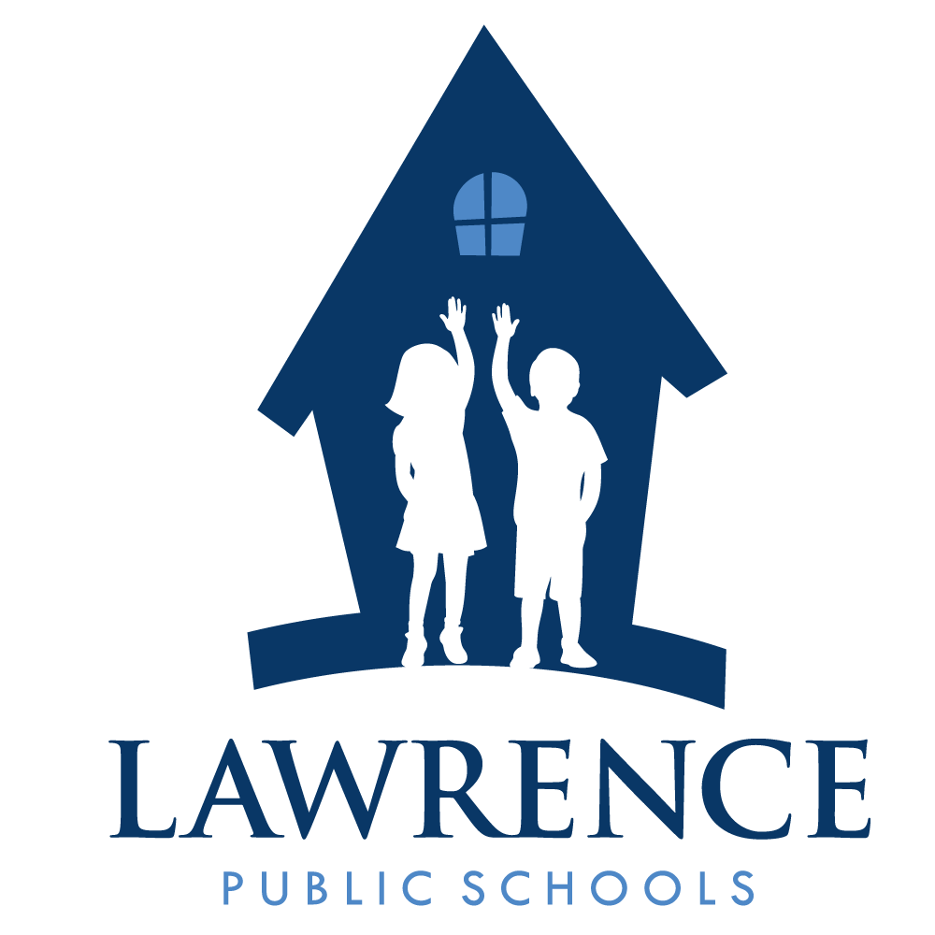
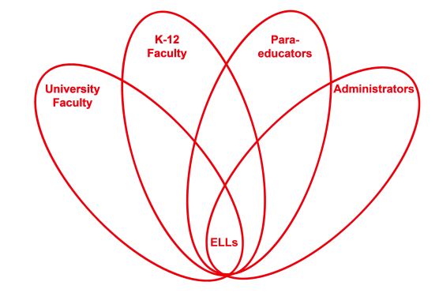

RETELL Strategy Implementation in the Classroom

Teacher | Eileen Lannan
Content Area /  Grade Level | Reading/ELA Grade 8
Unit  (Topic or Skill) | Civil Rights – Montgomery Bus Boycott
Content Objectives | Students will take a closer look at the different perspectives of the civil rights movement and demonstrate a clear understanding of the Montgomery Bus Boycott by completing a RAFT assignment.
Language Objectives | Students will create a written project and demonstrate understanding of content vocabulary in the reading and writing RAFT Strategy.  Level 3 - The students will be provided a word bank with short definitions to complete their RAFT assignment of (5) sentences.  Level 4 – The students will be provided a word bank to complete their RAFT assignment of (8) sentences.
Strategy  (Name or Type) | RAFT (Role, Audience, Format, Topic) Writing Activity
Brief explanation of how the strategy was used | The students have finished reading Freedom Walkers and just completed the reading of Malcolm X. The students will now use writing to take a closer look at the different characters’ perspectives. One of the strategies I chose to implement this week is the RAFT strategy as it incorporates student choice. The students will choose one of the following RAFTs from the attached student handout, and write at least five-eight complete sentences.  R stands for Role: This column tells you whose perspective you are writing from.  A stands for Audience: This column tells you who you are writing to.  F stands for Format: This column tells you the style of writing you will produce (letter, email, text message, speech, etc.).  T stands for Topic: This column tells you what you are writing about.
Reflection: How and why was the strategy effective? What might you change for next time? | This strategy served as the final reinforcement of previously taught concepts. Writing is one of the last domains to master, but with all the vocabulary and reading strategies implemented during this unit, it has definitely improved content comprehension. All of my students have benefited from the strategies meant for the ELLs and the Ells have gained a solid understanding of the key concepts at the same pace or very close to my other students. The strategies did not take long to prep for or to execute, and the payoff has been that content has been made comprehensible and the best part is – the enjoyment level of learning has increased and I enjoy my students more and I enjoy seeing the gains made this term. The gains are directly related to the strategies implemented. RAFT was successful for many reasons, but primarily it gave the students a say or a choice.  RAFT is an effective writing strategy because;  • It includes writing from different viewpoints.  • It helps students learn important writing skills such as audience, main idea, and organization.  • It teaches students to think creatively about writing by responding to the prompts of RAFT.  • It can be used across various content areas  A better reader is created by reading--especially aloud. Reading makes better writers by expanding vocabulary and also providing new ways to look at the world. Without the tools of the trade--words and experience, writing doesn't usually go anywhere. I think that writing can help make content comprehensible at upper levels in two ways.  1. One is that when students have to write about their reading it holds them accountable. Knowing that you're going to need to write an essay about the injustices of civil rights makes you read the related texts more carefully and fully, if you do that enough it becomes a habit.  2. The other is that if you're receiving instruction in writing, and exploring various literary devices such as point of view, you're going to become more aware of them in your reading as well.  I believe that academic language and discourse should be a part of everyday class expectations. The RAFT strategy helped the students produce academic language because they are guided into a character’s perspective and that will naturally produce language associated with a particular character’s point of view. The students love to talk about what they are learning and are very willing to help each other out. I also believe the strategies implemented throughout my civil rights unit have been extremely beneficial at every level. When you put them altogether and look at the increased participation, it can be attributed to a greater, overall understanding of the reading. Discussions are a great opportunity for practicing academic language use and also for assessing understanding. It can be informal and fun at the same time. I give verbal praise when students use academic language or I will stop them in mid-sentence and say, “what is the vocabulary word for that?” I’ve been known to throw out an extra piece of candy for really impressive discussions. That helps! It also helps when the content is high interest reading and the teacher is enthusiastic about teaching it.  The next time I implement this strategy I would probably limit the choices in the RAFT student handout. This change in implementation does not affect student engagement; it is more a change I would make for time management purposes. The students were so excited about the choices they had a hard time focusing on one; they were just ‘lovin’ the choices. They were acting out some good responses, and we had a couple of good laughs. Then, they wanted to do more than one RAFT and still could not pin it down to two. Sometimes too many choices is just too many choices. I just got carried away when I created the RAFT choices as I wanted them to have plenty to choose from. Next time, I would cut the choices in half or do it a couple of times throughout the unit. Maybe the student’s second choice could be something they didn’t pick in the first round. Student engagement throughout this unit was terrific and I enjoyed this lesson as well.

**See materials and resources on the following pages.**

Freedom Walkers/Malcolm X : RAFT Activity
Now that you have finished reading Freedom Walkers and Malcolm X, you will use writing to take a closer look at the different characters’ perspectives. Choose one of the following RAFTs below, and write at least five-eight complete sentences.

R stands for Role: This column tells you whose perspective you are writing from.
A stands for Audience: This column tells you who you are writing to.
F stands for Format: This column tells you the style of writing you will produce (letter, email, text message, speech, etc.).
T stands for Topic: This column tells you what you are writing about.

R | A | F | T
Jo Ann Robinson, WPC | Mayor W.A. Gayle | Angry letter | Threatening a city wide boycott if you do not meet our demands
Alabama Police Chief | Dr. King | Phone conversation | You need to stop organizing blacks, we will not protect you
NAACP | Rosa Parks | Text Message | We think you should take your case to the U.S. Supreme court
KKK | KKK Members | Memo | Scare tactics & intimidation by any means necessary
Women’s Political Council | Black Residents | Flyer | Don’t ride the bus
Dr. King | Church community | Speech | We should fight with non-violent protest
Rosa | Historians | Billboard Bus Ad | I didn’t start the boycott…
Boycott busses | Freedom ride busses | Lament (Mourn) | Where have all my riders gone?
Montgomery Marchers | Protesters of the marchers | Marching Song | A long, long way to go…
Coretta Scott King | Her children | Children’s book | Father’s story
You | Citizens of Lawrence | Radio address | Make a plea to the citizens to stop racist acts
Teacher | Students | Timeline | Ten important moments in civil rights history
Malcolm X | Therapist | Discussion | The reasons I feel so angry.

