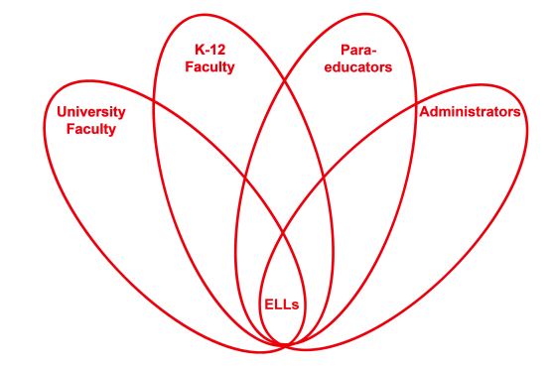

RETELL Strategy Implementation in the Classroom

Teacher | Joshua Segaloff
Content Area /  Grade Level | Science Middle School Grade 7
Unit | Nonfiction writing from Round Earth topic
Content Objectives | I will use a RAFT writing template to organize my facts about evidence for a round earth.
Language Objectives | I will read a nonfiction article and write evidence about a round earth by using a RAFT template.  Language Objective Differentiation for Proficiency Levels:  - I will identify main idea and supporting details.  - I will write a simple expository text.  - I will write opinions, preferences, and reactions along with reason.  - I will discuss with partners the main idea from the text.
Strategy | R.A.F.T. (Role, Audience, Format, Topic)
Brief explanation of how the strategy was used | Students have previously worked in pairs to read the nonfiction text and annotate the article on round Earth. Students are introduced to the RAFT template, R=scientist, A=scientific debate, F=persuasive speech, T=proof the earth is round. Students work with partners to identify 5 pieces of evidence from the text that will be used in the speech. The students begin to write a rough draft based off of the template.
Reflection: How and why was the strategy effective? What might you change for next time? | The RAFT strategy helped make the content comprehensible to my students because they could focus on specific role of writing and who is the audience. My students knew to look for scientific information about a round earth and that they would have to convince a scientific community that the earth is round.  The academic language increased through this activity because students had to share their annotations and supporting evidence. Students had to speak with partners and provide reasoning for why the evidence they chose should be included in the speech. By writing a draft and then reading it to a partner, the student uses academic language that includes tier 2 and tier 3 vocabulary.  The next time I would complete this strategy I would have my students revise and edit their writing of the speech. I would expect a formal written sample to be handed in. This time I accepted a rough draft and we had a class discussion trying to persuade me that the Earth is round. I would provide more models of the template for my low level students and use more sentence frames to help them start their speech.

**Please see the R.A.F.T. template Mr. Segaloff
created for this lesson on the next page**

Role = Scientist | Audience = Scientific debate | Format = Persuasive speech | Topic = Proof that the Earth is round

