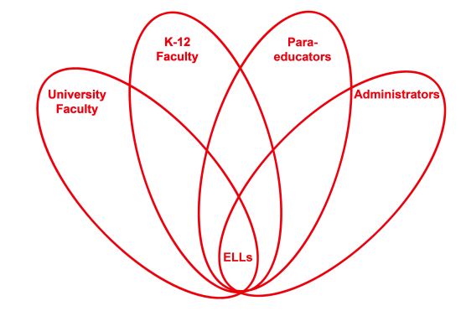



**RETELL Strategy Implementation in the Classroom**

|  |  |
| --- | --- |
| **Teacher** | Paul Flanigan |
| **Content Area /**  **Grade Level** | Science Grade 5 |
| **Unit** | Simple Machines |
| **Content Objectives** | Students will be introduced to the six simple machines and begin to see the advantages that they provide. |
| **Language Objectives** | Students will write their solution to a problem that is presented to them. Students will also be able to talk about their solution if they choose to. |
| **Strategy** | Quick Write |
| **Brief explanation of how the strategy was used** |  |
| **Reflection: How and why was the strategy effective? What might you change for next time?** | This strategy helped the students produce academic language by providing them with a non-threatening opportunity to write about their ideas. Also, in the follow-up, we verbally shared our ideas. During this, I asked some of the students to further explain what they had written. I had them explain when they used academic words such as lever, pulley, wheel, etc. This allowed the students to be exposed to these academic words.  The next time I try this strategy, I would again allow them to expand on what they wrote when we shared. I felt this was a great opportunity for them to use academic language on their own terms. They had used the terms in their writing which showed they had some ownership of them. When they shared them verbally, they did so in their own words which were easier for all of the other students to understand. |