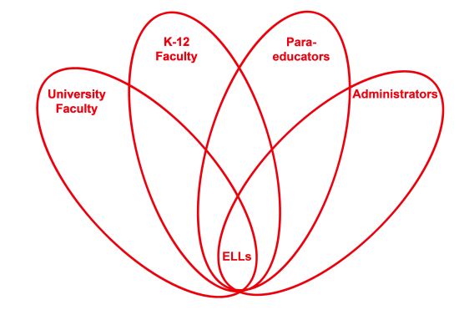

RETELL Strategy Implementation in the Classroom

Teacher | Melissa Carter
Content Area /  Grade Level | Health/ Gr.3
Unit | Strategies for Victims of Bullying
Content Objectives | Students will be able to recall and explain strategies a victim can use to stop a bully.
Language Objectives | CCSS.ELA-Literacy.W.3.1 Write opinion pieces on topics or texts, supporting a point of view with reasons.  CCSS.ELA-Literacy.W.3.1a Introduce the topic or text they are writing about, state an opinion, and create an organizational structure that lists reasons.  CCSS.ELA-Literacy.W.3.1b Provide reasons that support the opinion.  CCSS.ELA-Literacy.W.3.1c Use linking words and phrases (e.g., because, therefore, since, for example) to connect opinion and reasons.  CCSS.ELA-Literacy.W.3.1d Provide a concluding statement or section  Students will be able to explain a way to stop a bully through writing a prediction on what Pinky might do to stop being bullied.  Language Objective Differentiation for Proficiency Levels:  Level 1 & 2  Students will be able to explain a way to stop a bully through writing simple sentences on what Pinky might do to stop being bullied using a phrase bank.
Strategy | Phrase Bank Roundtable
Brief explanation of how the strategy was used | -Review through turn and talk with a partner what is bullying and how to stop a bully.  -Introduce through seven step process new vocabulary from the story.  -Read first three chapters of “Pinky and Rex and the Bully” by James Howe.  -Discuss how Pinky was bullied, what did Pinky do to stop the bully, what should he do, did anyone else help Pinky, and what would you tell Pinky to do.  -Brainstorm a list of predictions of what the class thinks will happen next in the story and how Pinky might stop being bullied.  -Have students in a roundtable pass a paper to each person in their group to predict all the ways Pinky could stop being bullied. The paper on the top will state “I think Pinky will”. Each student will finish with a phrase on how they think Pinky will stop the bully.  -Model and have students write and draw a prediction using a sentence starter and vocabulary list of how they think Pinky will try to stop the bully and explain why. They will use the list generated by the roundtable to write what they think Pinky will do in the end of the story.
Reflection: How and why was the strategy effective? What might you change for next time? | The roundtable assisted my ELLS by making it easier for them to understand the different ways to stop a bully. They had an opportunity to work within a group to discuss ways to stop bullying and to write down strategies to stop the bully as well. It helped to reinforce the strategies a victim can use. The roundtable helped my ELLs in my classroom to be able to write their own sentences and create a prediction by using the samples that were shown in their roundtable. It provided them with a phrase bank to use for their predictions.  Next time I try this strategy I will use it to a create list of vocabulary terms that they associate with a given topic to create a word wall. I will also make sure to emphasize not to repeat an idea. I also might have students buddy up in the roundtable so they can come up with words or phrases as partners.

