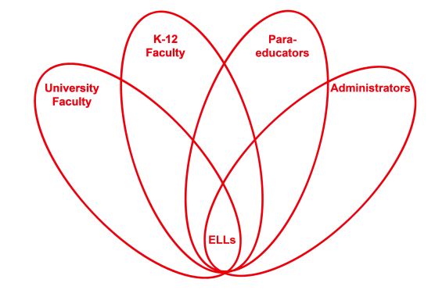

RETELL Strategy Implementation in the Classroom

Teacher | Diane Fortier
Content Area /  Grade Level | Kindergarten
Unit  (Topic or Skill) | Partner Reading
Content Objectives | Students will ‘read’ a leveled reading book in English by repeating words after model.
Language Objectives | Students will read a book orally by repeating each sentence as it is read.  This was a targeted lesson for the level 1 students. Other students were doing independent reading or a different partner share variation.
Strategy  (Name or Type) | Variation 1 “Newcomer Trio” Partner Reading
Brief explanation of how the strategy was used | Two partner reading groups were formed. The groups consisted of one Level 1 ELL student paired with one level 4 ELL and one native language student. Group 1 had a girl level 1 ELL and group 2 had a boy level 1 ELL.  Students were instructed to read one chosen book together using the following format:  Native language student read sentence, level 4 student repeated the sentence, then Level 1 student repeated the sentence. Native language student read next sentence. Process continued until entire book was read.  After book was complete, students returned to their seats with their book bag and read independently for remaining lesson time.  At the end of the lesson two students were asked to share what they did during the lesson.
Reflection: How and why was the strategy effective? What might you change for next time? | This strategy was effective for one student but not another.  Having the students repeat the sentences after a role model was very empowering for one of the Level 1 students. These two students struggle with the flow of saying English words. When they go to Independent Reading they are not using the reading skills on their own. They stumble on saying the vocabulary. They lose focus fast. This strategy gave them the ability to ‘read’ a book from start to finish with a model.  The two ELLS that were targeted for this strategy handled it very differently. The girl in the first group was completely focused on pointing to the words in the book and repeating the words. When the book was finished she returned to her seat with her book bag, proceeded to re-read that book, opening a discussion with others at her table. She was so proud that she could point to the words and talk about the story. When it was share time she volunteered to talk about her book. She was able to read some of the pages in her book.  The boy in the second group had great difficulty repeating the words. As he stumbled, the others would repeat the words and he would try again. His effort was very good but many of the words came out unclear and he could not get a sentence to flow. He was frustrated. The other students were respectful of his efforts but clearly wanted him to be more successful. When the book was done, he went back to his seat, put the book away, and chose a different book. He flipped through that book quickly not really focusing on any particular page or reading strategy. He did engage the person next to him by laughing and saying something that was unrelated to any story.  The level 4 students both repeated the words eagerly and I will target them next in a partner share group where they will discuss vocabulary.  I would use this strategy for the girl again. She really responded to being able to be a success and read the book clearly. She was happy to go show her skills to others. Her book talk was better as she went back to her table and talked due to this strategy.  I would not ask the boy to do it this way again. It clearly was not effective for him. The book was a beginning A level book. There were not any words he had not been exposed to before. I was watching to see if in a small group that had other Spanish speaking students, he would feel comfortable and be able to repeat words enough to be understood. That was not the case. Results of this lesson will be placed in his portfolio. I will talk with his parents and see if he has the same difficulty talking or repeating things in Spanish. That will inform me whether any additional services need to be accessed. Within the classroom, I will begin instructing him in a very small group to do some single sound repetition and mouth movement activities.

