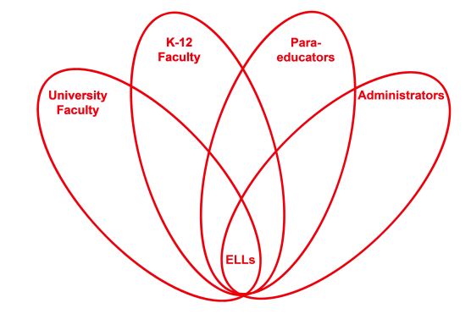

RETELL Strategy Implementation in the Classroom

Teacher | Elisha Ayala
Content Area /  Grade Level | 5th Grade Math
Unit | Number Sense and Operations Open Responses
Content Objectives | We will determine the correct operation, write an equation, and calculate the answer when answering an open-response question.
Language Objectives | Students will explain how they calculated their answer when answering each part of the open-response question.  Language Objective Differentiation for Proficiency Levels:  Level 1: Students will communicate ideas by writing equations, using symbols, and pictures.  Level 2: Students will write simple sentences using words from math word wall.  Level 3: Students will describe the procedure they used to calculate the answer using words from the math word wall.  Level 4: Students will explain strategies they used when solving each part of the open-response question.  Level 5: Students will apply content-based knowledge in their written explanation for each part of the open-response question.
Strategy  (Name or Type) | Partner Reading: Variation 3  Partner #1 reads aloud one sentence.  Partner #2 questions or comments about the content, language structure, or word from the sentence Partner #1 just read.  Partner #1 responds. Partners switch.
Brief explanation of how the strategy was used | This strategy was modified so that it could be used during a Math class. This strategy was used when students were answering an open-response question. First, students were asked to read the open-response question silently and underline key words that would help them calculate the answer. Students had to rely on previous strategies used in class to do this part independently (Word Wheel / Text Features).
Reflection: How and why was the strategy effective? What might you change for next time? | This strategy is a great cooperative learning strategy which encourages students to work together and rely on one another. ELL students who do not feel comfortable speaking aloud in a whole group setting benefit from this strategy. I made sure to partner ELL students with more dominate English speakers so that my ELLs would have a model of fluent reading. Partner reading (Variation #3) gave my students the opportunity to take turns reading and provide each other with feedback as a way to monitor each other’s comprehension of the question.  This strategy encouraged students to use the academic language during their discussion with their partner. Students had to think about what the question was asking and then discuss it with their partner. Clarifications were made by either partner to help them understand each part of the open-response question. If students can explain what they’ve read to their partner, this indicates that they understood the content. This strategy also provides direct opportunity for the teacher to circulate the classroom and listen to student discussions to see if the student comprehends what they are reading. Teachers can also offer individual remediation and check for understanding.  To increase my ELLs’ engagement and interaction, the next time I try this strategy, I would write out sentence starters for my ELL students to use when it is their turn to question or comment about the content they just read.

