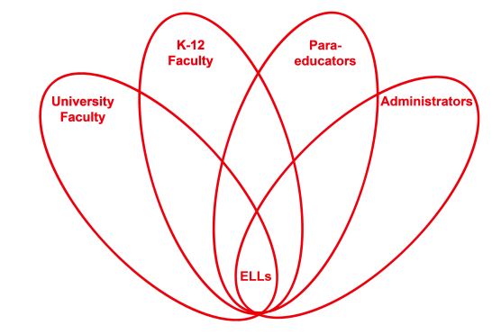

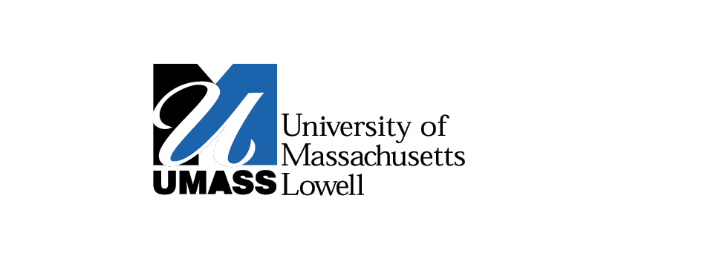

**RETELL Strategy Implementation in the Classroom**

|  |  |
| --- | --- |
| **Teacher** | Paul Flanigan |
| **Content Area /**  **Grade Level** | Science Grade 5 |
| **Unit**  **(Topic or Skill)** | Simple Machines |
| **Content Objectives** | Students will understand that when using the lever, the farther out on the lever arm the effort is applied, the less the effort. |
| **Language Objectives** | Students will be able to use the vocabulary words properly by writing them each in the appropriate sentences. |
| **Strategy** | Language Experience Approach and Paragraph Frame |
| **Brief explanation of how the strategy was used** | This lesson was part of a follow-up to an experiment we did in class using levers. We reviewed the steps and vocabulary from the experiment and the data we collected. |
| **Reflection: How and why was the strategy effective? What might you change for next time?** | This strategy helped to make the content comprehensible by making a writing activity less stressful on the ELLs. The key vocabulary words were focused in on but the burden of writing the paragraph was removed. Also, since this activity followed an experiment that they had performed it allowed them to relate to their own experience.  The next time I try this strategy, I would try this same strategy with the next experiment we are performing. This would be effective for me to see if they reach the objective because though the experiment is similar in many ways, its outcome and concept are different. This similar format but differing outcome would show me if the students are able to distinguish between them. |