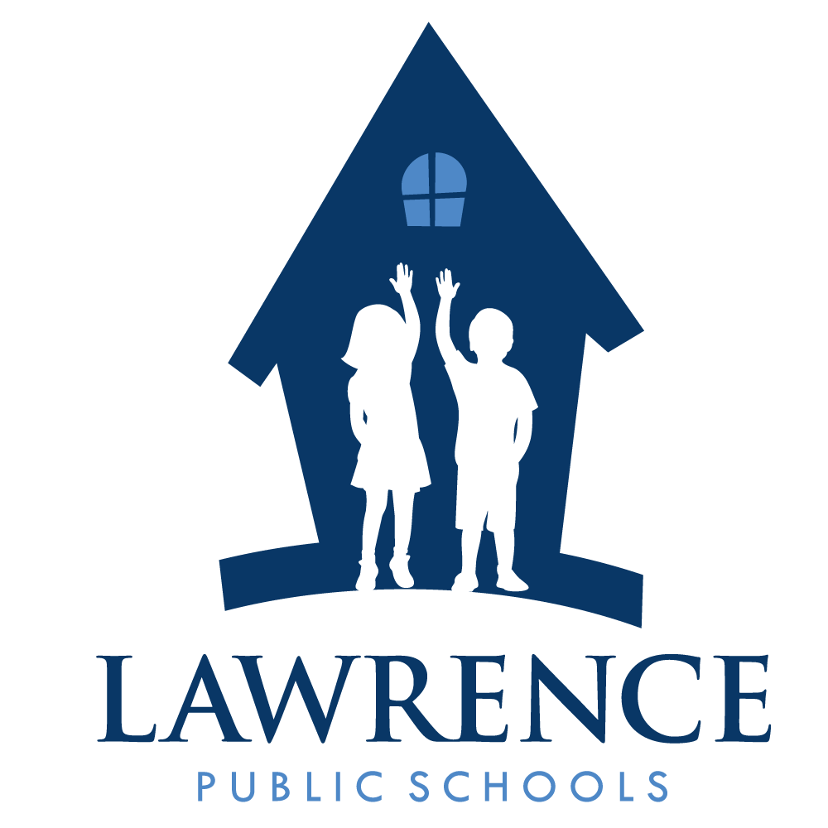
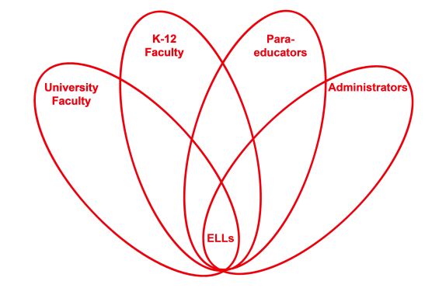

RETELL Strategy Implementation in the Classroom

Teacher | Sonya Dugan
Content Area /  Grade Level | 2nd Grade ELA
Unit  (Topic or Skill) | Writing
Content Objectives | Students will be able to recognize and describe events that took place during a specified time in the classroom.
Language Objectives | Students will be able to identify and share 3 events from Polar Express Day, share their feelings about it, and provide one fact to prove their feelings.  Language Objective Differentiation for Proficiency Levels:  Students at WIDA level 2:  - students will be able to orally state events he/she experienced during Polar Express Day  - students will be able to have conversation using details from day  - students will be able to provide information using a graphic organizer (adding to chart paper)  Students at WIDA level 3:  - students will be able to orally state and/or write at least 2 events he/she experienced during Polar Express Day  - students will form simple sentences using events in context (author, illustrator...)  - students will be able to provide information using an individual graphic organizer
Strategy | Writing using the Language Experience Approach
Brief explanation of how the strategy was used | 1. Record student's answers to the following prompts on board (or chart paper):  Celebrating Polar Express Day was a great experience. We did many fun activities. First, we __________. Then, we ____________. Last, we__________. Our Polar Express Day was ______ because_______.  2. Read back to students the recorded information to make sure it is what they want to say.  3. Make changes that student(s) want to make.  4. Read and reread the produced story (track as you read together.
Reflection: How and why was the strategy effective? What might you change for next time? | This strategy allowed my ELL students to feel successful because they were able to share the events of the day without having to come up with all of the details individually. They were able to converse about the events of Polar Express Day. Although they were not able (in some instances) to read what was written on the chart, they were able to fully participate as it was read to them and they enjoyed having a conversation about their day.  Due to the nature of this celebration, there was not a lot of academic language in this particular assignment. However, the students were able to produce appropriate and on-topic language related to the events that led up to Polar Express Day as well as the movie and day itself - and share these events with the small group.  The next time I try this strategy, I would not do it when they were still wearing their pajamas and had stuffed animals in their possession. This was a very excitable day for the students. Earlier in the week, many discussions were had about holidays and different celebrations. They also read Mrs. Claus Explains it All. After they read the story, they wrote notes to Mrs. Claus if they still had any questions that they needed answered. Lucky for me, Mrs. Claus wrote them back and sent them some bells to enjoy while watching The Polar Express - while in PJ's and with blankets and stuffed animals. Needless to say, they were very excited from all this. That being said, they did a great job on this assignment. They were very involved and enjoyed seeing their events unfold in a story.

