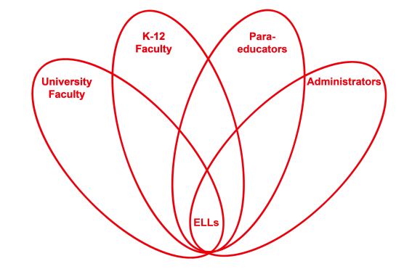

RETELL Strategy Implementation in the Classroom

Teacher | Carlene Hackett
Content Area /  Grade Level | Reading/Social Studies  Grade 4
Unit  (Topic or Skill) | Westward Expansion
Content Objectives | Students will refer to details and examples in a text when explaining what the text says.
Language Objectives | Students will use text to describe the events in Laura Ingalls Wilder’s life.
Strategy | Jigsaw
Brief explanation of how the strategy was used | Nonfiction text: Who was Laura Ingalls Wilder?  This strategy is used to have students share one chapter of a non-fiction book to their classmates. It breaks it down into smaller sections and they get to work in cooperative groups. The class is split into 4 groups of 6; these groups are called the expert groups. Each group takes a chapter of the nonfiction book, “Who Was Laura Ingalls?” Each member has their own copy; they read the chapter together, highlighting the important facts. These groups discuss the chapter together. A few days later, expert groups are split up and are now on their own in a new group, one person for each chapter, 6 groups of 4. At this point each person shares the important parts of their chapter. Students will have all their notes from the “expert” group which will help the ELL students as well as SPED students.  On the next day we will come together to discuss each chapter and the importance of each chapter.
Reflection: How and why was the strategy effective? What might you change for next time? | This strategy worked better than I had anticipated since all students are on their own after working with their expert groups. Students need a few days working and feeling comfortable about sharing their chapter to others. It is good for all students to have copies of their own chapter so they have something to guide them in the discussions.  Next time I would make sure all groups have equal amount of leveled students, making sure ELL and SPED students are split up evenly in all groups.

