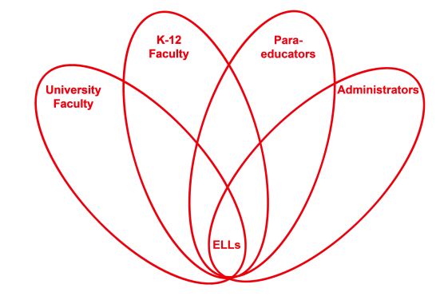

RETELL Strategy Implementation in the Classroom

Teacher | Linda Fiorillo
Content Area /  Grade Level | Literacy/Kindergarten
Unit  (Topic or Skill) | The Gingerbread Baby-identifying setting, characters, and plot
Content Objectives | With prompting and support, students will identify characters, settings, and major events in the story The Gingerbread Baby.
Language Objectives | Students will be able to tell about the characters, the setting and basic plot of the story, “The Gingerbread Baby.”  Language Objective Differentiation for Proficiency Levels:  L1 Students can tell or draw pictures of their conclusion to  the “Gingerbread Baby.”  L2 Students can write vocab words on board or sound out a  word or two to describe their own version of the  conclusion of the, “Gingerbread Baby.”  L3 Students can write a sentence or two about their own  version of the conclusion of the “Gingerbread Baby”
Strategy | “I wonder…” Strategy
Brief explanation of how the strategy was used | Lesson Sequence:  - Discussion of “I wonder”…strategy for reading as a way to think about and identify characters, setting and plot.  - Teacher reads book pausing to demonstrate the “I wonder” strategy  - Teacher continues to use strategy to discuss which characters will come next in story  - Students partner talk  - Teacher continues and pauses to discuss setting changes  - Teacher reads and pauses and does not show children  the ending of story. Instead, she asks the children  to wonder…. And write a solution of what they  think will happen  - Teacher calls group together and reads responses and then reads the ending and compares answers  - Conclusion: Good readers can use the I wonder strategy… as they read books to identify characters, plot, and setting.
Reflection: How and why was the strategy effective? What might you change for next time? | I had fun with this strategy and I would definitely use it again. I was so animated and I would peek between the pages and not let the students see and would say I wonder…. And then show them the pages and characters etc. The, “I wonder” strategy really stimulated their imaginations, curiosity and interest in the story. The students were very attentive and were truly connected to the story. It slowed down the process so that the children could take time to think about what was going on in the book and to concentrate on the characters, setting and plot in a fun and animated way. This strategy allowed the students to use the vocabulary words and academic words such as conclusion, characters, etc. They wanted to write their own responses and they could not wait to share. I loved this strategy and the students did too. They acted out the story at recess and used puppets to retell the story later in centers.  I think modeling is always important because the students can see exactly what is expected of them. If they see it then they will know how to do it. When the students were in partners, I saw some children pointing to their heads and looking up with saying, “I wonder” just like I did in the group lesson. They were using the words, “I wonder” and were talking and listening to each other’s responses while concentrating on words such as character, plot and setting.  This strategy was a great one for promoting listening for it forced the children to think about academic language in a fun way. The children could not wait to participate in speaking-all hands were up to share responses!!! They crowded me to get their piece of paper to write their responses. As I went around the room as they were writing, I heard one kid say to another who just entered the room from speech class, “You are supposed to wonder about what happened to the Gingerbread Baby and the teacher said to write it on your paper. Then my top student corrected the boy and said, “write the conclusion of the story.” He got a big pat on the back. I was so proud of him. I loved the sharing of responses partly because the students were very excited to show their pictures and read the words and sentences they wrote to describe their answers.  To increase my ELLs’ engagement and interaction, the next time I try this strategy, I would make an anchor chart and have a picture of a person thinking with a big cloud. I would laminate the chart. Then when I used the, “I wonder strategy”, I could write in the cloud all the things wondered about and it could be posted in the classroom. Also as the children wondered about things, I could write down their responses or the partner responses thus adding another domain to language learning.

