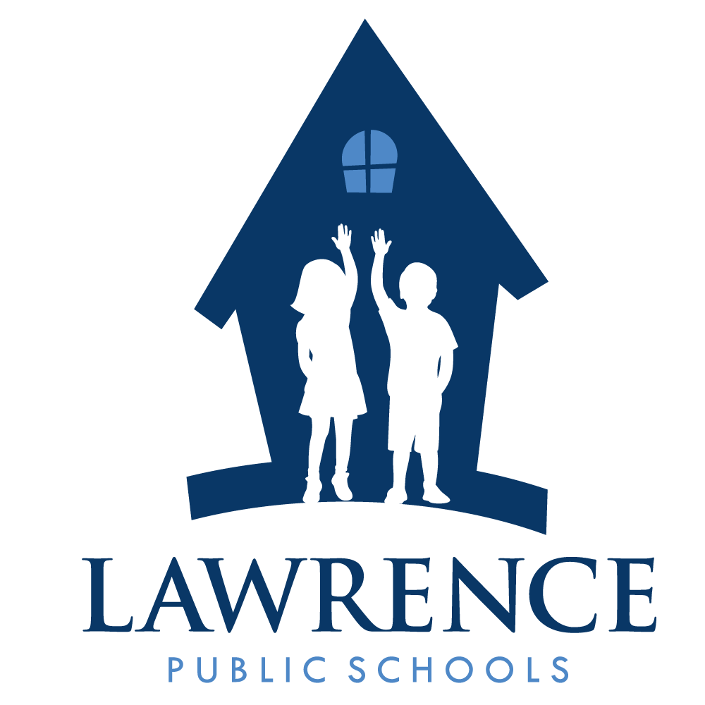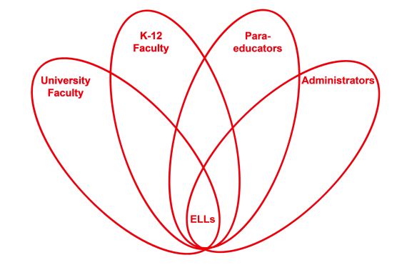



**RETELL Strategy Implementation in the Classroom**

|  |  |
| --- | --- |
| **Teacher** | Eileen Lannan |
| **Content Area /**  **Grade Level** | Reading/ELA Grade 8 |
| **Unit**  **(Topic or Skill)** | Civil Rights – Montgomery Bus Boycott |
| **Content Objectives** | Students will complete a graphic organizer as a pre-writing strategy to a newspaper article. |
| **Language Objectives** | Students will organize their ideas on a graphic organizer incorporating the content vocabulary learned in this unit.  Level3 – Student will organize ideas into bulleted phrases on graphic organizer that include at least (3) vocabulary words.  Level 4 Student will organize idea into complete sentences on graphic organizer that include at least (6) vocabulary words. |
| **Strategy**  **(Name or Type)** | Graphic organizer for Pre-Writing. |
| **Brief explanation of how the strategy was used** | **Final Project**: Students will create a 2-3 page newspaper about the important events of the Montgomery Bus Boycott. Must include: summary of important events, two pictures, photos, or illustrations with captions, and one in depth look into an important person from the boycott.  **Pre-writing Strategy:** Students will complete a graphic organizer as a pre-writing strategy for the final project outlined above.  [Image: Caption follows](http://lcweb.loc.gov/exhibits/odyssey/archive/09/0903001r.jpg) |
| **Reflection: How and why was the strategy effective? What might you change for next time?** | Graphic organizers are a visual strategy used to assist students to grasp the “wholeness and parts” of a concept, making content more comprehensible to students. Using graphic organizers is a powerful strategy for helping all students and it especially helps English Language Learners with organizing and remembering information. Because graphic organizers are both visual and spatial, they help students retain concepts and assist students in recording personal understandings of a concept. Graphic organizers help simplify the learning process and produce understanding. Graphic organizers help to make the content comprehensible to ELLs because they do help students build a framework for learning key ideas and vocabulary and also help them form a deeper understanding. Most importantly, graphic organizers convert complex information into manageable chunks for ELL students.  All my students are grouped in fours. The Ells are spread out. Within groupings, collaboration among peers is expected and ELLs are required to use English to explain concepts and contribute to the discussions or work at hand. I, as a teacher can informally assess how members of the group talk, write, and participate in constructing knowledge. The students are encouraged to work together by reading and revising each other’s writing. ELLs, like other students, want to get their assignment right, so they will gladly ask a peer for clarification or help before I get to their table. When I conference with a student about their writing, it is a conversation between the two of us, thus, continuing the discourse and reinforcing the academic language use.  Graphic organizers are such a valuable tool, I can’t say anything negative. They are a necessary pre-writing strategy. For lower level students or ELLs, I may from time to time have to help them by providing sentence frames within the graphic organizer, have them bullet phrases, or maybe scribe their oral responses as a last resort. Other than that, graphic organizers are key to a student’s deeper understanding of concepts and a good pre-writing piece, if used properly. |

***\*\*See materials and resources on the following pages.\*\****



**Name: __________________________**

**Teacher: ________________________**

**Newspaper Article Planner – Research Guiding Questions**

**Directions:** Use this sheet to develop ideas for your 1-2 page newspaper article.

1. Specifically, when and where did your chosen event take place?

2. Who specifically was involved in this event? What roles did they play and why were they important?

3. What major factors contributed to the occurrence of this event? What happened prior to this event that caused it?

4. What was the immediate result of this event? How did this event effect social change/civil rights?

5. Find two major players in this event. Research what they have said in their own words and choose one comment from each that you would likely find in a news article about the event. Accurately quote them on this sheet.

a. Quote #1

b. Quote #2