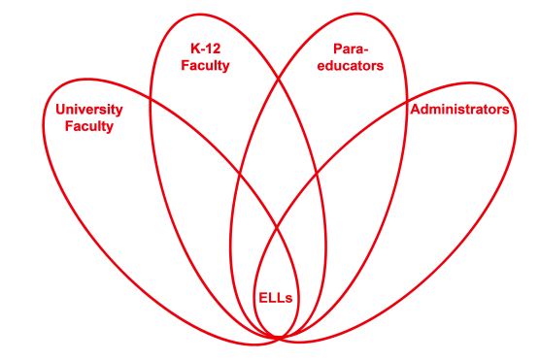

RETELL Strategy Implementation in the Classroom

Teacher | Paul Flanigan
Content Area /  Grade Level | Science Grade 5
Unit | Rocks and Minerals - Properties of Minerals
Content Objectives | Students will know the properties of minerals and how to test for these properties.
Language Objectives | The students will write in their own words a mineral property and how to test for it.
Strategy | Exit Ticket
Brief explanation of how the strategy was used | The Exit Ticket asked the students to choose a property of minerals and explain in their own words how to perform this test. The tickets were placed on the board as they exited.  As a follow-up, I assessed the Exit Tickets using an MCAS style rubric where they received a 1-4 for their writing.
Reflection: How and why was the strategy effective? What might you change for next time? | This strategy was very effective both for the students and me. It forced them to write out a procedure they had performed. For me, it was a very quick and easy way to assess their understanding of the concept.  Next time, I would perform this ticket a second time asking them to use a different property and test. This would allow me to see if they knew more than one and see if their writing improved.

